# Answers start here

# 1 Algebra

Many people dislike algebra; for many it is the point at which they start switching off mathematics. But do persevere – most of it is natural enough when you think about it the right way.

### 1.1 Simple algebraic expressions

Some very basic things here, but they should prove helpful.

Are you fully aware that  and  are the same thing?

***Example 1*** Find the value of *a* for which  is always true.

***Solution*** Dividing 8 by 11 and multiplying by (5*x* – 4) is the same as multiplying 8 by (5*x* – 4) and dividing by 11. So *a* = 11.

*You do not need to multiply anything out to see this!*

Remember that in algebraic fractions such as , the line has the same effect as a bracket round the denominator. You may well find it helpful actually to *write in* the bracket: .

***Example 2***Solve the equation 

***Solution*** Multiply both sides by (*x* – 2): 3 = 12(*x* – 2)

Multiply out the bracket: 3 = 12*x* – 24

Add 24 to both sides: 27 = 12*x*

Divide by 12: .

A common mistake is to start by dividing by 3. That would give  [*not* *x* – 2 = 4] and you will still have to multiply by (*x* – 2).

Don’t ever be afraid to get the *x*-term on the *right*, as in the last line but one of the working. After all, 27 = 12*x* means just the same as 12*x* = 27!

***Example 3*** Make cos *A* the subject of the formula *a*2 = *b*2 + *c*2 – 2*bc* cos *A*.

***Solution*** Here it is best to get the term involving cos *A* onto the left-hand side first, otherwise you are likely to get in a muddle with the negative sign. So:

Add 2*bc* cos *A* to both sides:*a*2 + 2*bc* cos *A* = *b*2 + *c*2

Subtract *a*2 from both sides:2*bc* cos *A* = *b*2 + *c*2 – *a*2

Divide by 2*bc*: 

Rearranging the Cosine Formula is always a dangerous area, as you may well have found at GCSE. Some people actually prefer to memorise this formula for cos *A*.

***Example 4*** Solve the equation 

***Solution*** Do ***not*** multiply out the brackets to get fractions – that leads to horrible numbers! Instead:

Multiply both sides by 15: 

Choose 15 as it gets rid of all the fractions.

Cancel down the fractions: 



*Now* multiply out: 18*x* + 27 = 28*x* – 63

90 = 10*x*

Hence the answer is *x* = 9

This makes the working very much easier. ***Please don’t*** respond by saying “well, my method gets the same answer”! You want to develop your flexibility and your ability to find the easiest method if you are to do well at A Level, as well as to be able to use similar techniques in algebra instead of numbers. It’s not just this example we are worried about – it’s more complicated examples of a similar type.

### Exercise 1.1

**1** Find the values of the letters *p*, *q* and *r* that make the following pairs of expressions always equal.

(a)  (b)  (c) 

**2** Solve the following equations.

(a)  (b)  (c) 

**3** Make cos *C* the subject of the formula *c*2 = *a*2 + *b*2 – 2*ab* cos *C*.

**4** (a)Multiply  by 8. (b) Multiply (*x* + 2) ÷ 3 by 12.

(c) Multiply by 6. (d) Multiplyby 8.

**5** Solve the following equations.

(a)  (b) 

(c) 

**6** Make *x* the subject of the following equations.

(a)  (b) 

**7** Simplify the following as far as possible.

(a)  (b) 

(c)  (d) 

### 1.2 Algebraic Fractions

Many people have only a hazy idea of fractions. That needs improving if you want to go a long way with maths – you will need to be confident in handling fractions consisting of letters as well as numbers.

Remember, first, how to multiply a fraction by an integer. You multiply only the top *[what happens if you multiply both the top and the bottom of a fraction by the same thing?]*

***Example 1*** Multiply  by 3.

***Solution*** 4 × 3 = 12, so the answer is .

Sometimes you can simplify the answer. If there is a common factor between the denominator (bottom) of the fraction and the number you are multiplying by, you can *divide* by that common factor.

***Example 2*** Multiply  by 3.

***Solution*** 39 ÷ 3 = 13, so the answer is .

You will remember that when you divide one fraction by another, you turn the one you are dividing by upside down, and multiply. If you are dividing by a whole number, you may need to write it as a fraction.

***Example 3*** Divide  by 5.

***Solution*** **, so the answer is .

But if you can, you divide the top of the fraction only.

***Example 4*** Divide  by 5.

***Solution*** , so the answer is . *Note* that you divide 20 by 5.

Do ***not*** multiply out 5 × 43; you’ll only have to divide it again at the end!

***Example 5*** Multiply  by 2.

***Solution*** 3× 2 = 6*x*, so the answer is . (*Not* !)

***Example 6*** Divide  by *y*.

***Solution*** , so the answer is . [Don’t forget to simplify.]

***Example 7*** Divide by *T*.

***Solution*** .

Here it would be wrong to say just , which is a mix (as well as a mess!)

***Double fractions, or mixtures of fractions and decimals, are always wrong.***

For instance, if you want to divide  by 2, you should not say  but .

This sort of thing is extremely important when it comes to rearranging formulae.

***Example 8*** Make *r* the subject of the equation *V* = π*r*2*h*.

Don’t “divide by ”.

***Solution*** Multiply by 2: 2*V* = π*r*2*h*

Divide by π and *h*:  = *r*2

Square root both sides: .

You should *not* write the answer as  or , as these are fractions of fractions.

Make sure, too, that you write the answer properly. If you write √2*V*/π*h* it’s not at all clear that the whole expression has to be square-rooted and you will lose marks.

If you do get a compound fraction (a fraction in which either the numerator or the denominator, or both, contain one or more fractions), you can always simplify it by multiplying all the terms, on both top and bottom, by any *inner denominators*.

***Example 9*** Simplify .

***Solution*** Multiply all four terms, on both top and bottom, by (*x* – 1):







You will often want to combine two algebraic expressions, one of which is an algebraic fraction, into a single expression. You will no doubt remember how to add or subtract fractions, using a common denominator.

***Example 10*** Simplify.

***Solution***Use a common denominator. [You must treat (*x* – 1) and (*x* + 1) as separate expressions with no common factor.]



 .

Do use brackets, particularly on top – otherwise you are likely to forget the minus at the end of the numerator (in this example subtracting -1 gives +1).

Don’t multiply out the brackets on the bottom. You will need to see if there is a factor which cancels out (although there isn’t one in this case).

***Example 11***Simplify .

***Solution*** A common denominator may not be obvious, you should look to see if the denominator factorises first.

 is a common factor, so the common denominator is .









If one of the terms is not a fraction already, the best plan is to make it one.

***Example 12*** Write  as a single fraction.

***Solution* **





This method often produces big simplifications when roots are involved.

***Example 13*** Write  as a single fraction.

***Solution*** 







It is also often useful to reverse this process – that is, to rewrite expressions such as . The problem with this expression is that *x* appears in more than one place and it is not very easy to manipulate such expressions (for example, in finding the inverse function, or sketching a curve). Here is a very useful trick.

***Example 14*** Write  in the form , where *a* and *b* are integers.

***Solution*** 

Write “the top” as “the bottom plus or minus a number”.





***Example 15*** Write the equation  without fractions.

(*A* and *B* are constants that remain in your answer.)

***Solution*** Multiply both sides by the common denominator, here (*x* – 2)(*x* + 1):



Cancel out the common factors.



This is an important technique in A Level.

### Exercise 1.2

**1** Work out the following. Answers may be left as improper fractions.

(a)  (b)  (c)  (d) 

(e)  (f)  (g)  (h) 

(i)  (j)  (k)  (l) 

(m)  (n)  (o)  (p) 

**2** Make *x* the subject of the following formulae.

(a) *A* = π*x*2 (b)  (c) (*u* + *v*) = *tx* (d) 

**3** Simplify the following compound fractions.

(a)  (b)  (c) 

**4** Write as single fractions.

(a)  (b)  (c) (d)  (e)  (f)  (g) 

**5** Write as single fractions.

(a)  (b)  (c) 

**6** Write the following in the form .

(a)  (b)  (c)  (d) 

**7** Write the following equations without fractions. (*A*, *B* etc. are constants that remain in your answers.)

(a) 

(b) 

(c) 

(d) 

(e) 

### 1.3 Quadratic Expressions

You will no doubt have done much on these for GCSE. But they are so prominent at A Level that it is essential to make sure that you are never going to fall into any traps.

First, a reminder that (a) (*x* + 3)2 is ***not*** equal to *x*2 + 9

(b)  is ***not*** equal to *x* + *y*.

It is terribly tempting to be misled by the notation into making these mistakes, which are really optical illusions. If you always remember that “square” means “multiply by itself” you will remember that

.

From this it follows, of course, that

= (*x* + 3),

so  *can’t* be *x* + 3.

In fact  does not simplify. Nor do  or . If you are tempted to think that they do, you will need to make a mental note to take care whenever one of these expressions comes up. You will certainly deal with many expressions such as (*x* + 3)2 + (*y* – 4)2 and you will need to be able to use them confidently and accurately.

A related process is to write a quadratic expression such as  in the form . This is called ***completing the square***. It is often useful, because  is not a very transparent expression – it contains *x* in more than one place, and it’s not easy either to rearrange or to relate its graph to that of .

Completing the square for quadratic expressions in which the coefficient of  is 1 (these are called ***monic quadratics***) is very easy. The number *a* inside the brackets is always half of the coefficient of *x*.

***Example 1*** Write *x* 2 + 6*x* + 4 in the form (*x* + *a*)2 + *b*.

***Solution*** *x* 2 + 6 *x* + 4 is a monic quadratic, so *a* is half of 6, namely 3.

When you multiply out (*x* + 3)2, you get *x*2 + 6*x* + 9.

[The *x*-term is always twice *a*, which is why you have to halve it to get *a*.]

*x*2 + 6*x* + 9 isn’t quite right yet; we need 4 at the end, not 9, so we can write

*x*2 + 6*x* + 4 = (*x* + 3)2 – 9 + 4

= (*x* + 3)2 – 5.

This version immediately gives us several useful pieces of information. For instance, we now know a lot about the graph of *y* = *x*2 + 6*x* + 4:

* It is a translation of the graph of *y* = *x*2 by 3 units to the left and 5 units down
* Its line of symmetry is *x* = –3
* Its lowest point or vertex is at (–3, –5)

We also know that the smallest value of the function *x*2 + 6*x* + 4 is –5 and this occurs when

*x* = –3.

And we can solve the equation *x*2 + 6*x* + 4 = 0 *exactly* without having to use the quadratic equation formula, to locate the roots of the function:

*x*2 + 6*x* + 4 = 0

⇒ (*x* + 3)2 – 5 = 0

⇒ (*x* + 3)2 = 5

⇒ (*x* + 3) = ± √5 [don’t forget that there are two possibilities!]

⇒ *x* = –3 ± √5

These are of course the same solutions that would be obtained from the quadratic equation formula – not very surprisingly, as the formula itself is obtained by completing the square for the general quadratic equation *ax*2 + *bx* + *c* = 0.

**Non-monic quadratics**

Everyone knows that non-monic quadratic expressions are hard to deal with. Nobody really likes trying to factorise 6*x*2 + 5*x* – 6 (although you should certainly be willing and able to do so for A Level, which is why some examples are included in the exercises here).

***Example 2*** Write 2*x*2 + 12*x* + 23 in the form *a*(*x* + *b*)2 + *c*.

***Solution*** First take out the factor of 2:

2*x*2 + 12*x* + 23 = 2(*x*2 + 6*x* + 11.5) [you can ignore the 11.5 for now]

Now we can use the method for monic quadratics to write

*x*2 + 6*x* + 11.5 = (*x* + 3)2 + (something)

Half of 6

So we have, so far

2*x*2 + 12*x* + 23 = 2(*x* + 3)2 + *c* [so we already have *a* = 2 and *b* = 3]

Now 2(*x* + 3)2 = 2(*x*2 + 6*x* + 9)

= 2*x*2 + 12*x* + 18

We want 23 at the end, not 18, so:

2*x*2 + 12*x* + 23 = 2(*x* + 3)2 – 18 + 23

= 2(*x* + 3)2 + 5.

If the coefficient of *x*2is a perfect square you can sometimes get a more useful form.

***Example 3*** Write 4*x*2 + 20*x* + 19 in the form (*ax* + *b*)2 + *c*.

***Solution*** It should be obvious that *a* = 2 (the coefficient of *a*2 is 4).

So 4*x*2 + 20*x* + 19 = (2*x* + *b*)2 + *c*

If you multiply out the bracket now, the middle term will be 2 × 2*x* × *b* = 4*bx*.

So 4*bx* must equal 20*x* and clearly *b* = 5.

And we know that (2*x* + 5)2 = 4*x*2 + 20*x* + 25.

So 4*x*2 + 20*x* + 19 = (2*x* + 5)2 – 25 + 19

= (2*x* + 5)2 – 6.

### Exercise 1.3

**1** Write without brackets.

(a) (*x* + 5)2 (b) (*x* – 4)2 (c) (2*x* + 1)2

(d) (3*x* – 2)2 (e) (*x* + 2)(*x* – 2) (f) (3*x* + 4)(3*x* – 4)

**2** Simplify the following equations into the form *ax* + *by* + *c* = 0.

(a) (*x* + 3)2 + (*y* + 4)2 = (*x* – 2)2 + (*y* – 1)2

(b) (*x* + 5)2 + (*y* + 2)2 = (*x* – 5)2 + (*y* – 2)2

(c) (2*x* + 1)2 + (*y* – 3)2 = (2*x* + 3)2 + (*y* + 1)2

**3** Simplify the following where possible.

(a)  (b)  (c) 

(d)  (e)  (f) 

**4** Write the following in the form (*x* + *a*)2 + *b*.

(a) *x*2 + 8*x* + 19 (b) *x*2 – 10*x* + 23 (c) *x*2 + 2*x* – 4

(d) *x*2 – 4*x* – 3 (e) *x*2 – 3*x* + 2 (f) *x*2 – 5*x* – 6

**5** Write the following in the form *a*(*x* + *b*)2 + *c*.

(a) 3*x*2 + 6*x* + 7 (b) 5*x*2 – 20*x* + 17 (c) 2*x*2 + 10*x* + 13

**6** Write the following in the form (*ax* + *b*)2 + *c*.

(a) 4*x*2 + 12*x* + 14 (b) 9*x*2 – 12*x* – 1 (c) 16*x*2 + 40*x* + 22

**7** Factorise as fully as possible.

(a) *x*2 – 25 (b) 4*x*2 – 36 (c) 4*x*2 – 9*y*4

(d) 3*x*2 – 7*x* + 2 (e) 3*x*2 – 5*x* + 2 (f) 6*x*2 – 5*x* – 6

(g) 8*x*2 – 2*x* – 15

**8** Multiply out and simplify.

(a)  (b)  (c) 

### 1.4 Cancelling

The word “cancel” is a very dangerous one. It means two different things, one safe enough and the other very likely to lead you astray.

You can cancel *like terms* when they are added or subtracted.

***Example 1*** Simplify (*x*2 – 3*xy*) + (3*xy* – *y*2).

***Solution*** (*x*2 – 3*xy*) + (3*xy* – *y*2) = *x*2 – ~~3~~*~~xy~~* + ~~3~~*~~xy~~* – *y*2 = *x*2 – *y*2.

The “3*xy*” terms have “cancelled out”. This is safe enough.

It is also usual to talk about “cancelling down a fraction”. Thus  = . However, this tends to be very dangerous with anything other than the most straightforward numerical fractions. Consider, for instance, a fraction such as . If you try to “cancel” this, you’re almost certain not to get the right answer, which is in fact  (as we will see in Example 4, below).

Try instead to use the word “divide”. What happens when you “cancel down”  is that you *divide top and bottom* by 5. If you can divide both the top and bottom of a fraction by the same thing, this is a correct thing to do and you will get a simplified answer.

Contrast these two examples:  and .

In the first, you can divide both 4*x* and 8*y* by 4 and get *x* + 2*y*, which is the correct answer (though it is rather safer to start by factorising the top to get 4(*x* + 2*y*), after which it is obvious that you can divide top and bottom by 4.)

In the second example, you don’t do the same thing. 4*x* × 8*y* = 32*xy*. This can be divided by 4 to get 8*xy*, which is the correct answer. Apparently here only one of the two numbers, 4 and 8, has been divided by 4, whereas before both of them were. That is true, but it’s not a very helpful way of thinking about it.

With problems like these, start by multiplying together any terms that you can (like the 4*x* and the 8*y* in the second example). Then, if you can, factorise the whole of the top and/or the bottom of a fraction before doing any “cancelling”. Then you will be able to see whether you can divide out any common factors.

***Example 2*** Simplify .

***Solution*** 

The top factorises as 2(2*x* + 3*y*). The bottom factorises as 6(2*x* + *y*).

2 and 6 have a common factor of 2, which can be divided out to give 3.

But (2*x* + 3*y*) and (2*x* + *y*) have *no common factor* (neither 2 nor *x* divides into 3*y* or *y*, and neither 3 nor *y* divides into 2*x*).

So you can’t go any further, and the answer is .

***Example 3***Explain why you cannot cancel down .

***Solution*** There is nothing that divides all four terms (*x*2, 3*y*2, 3*x*2 and 1), and neither the top nor the bottom can be factorised. So nothing can be done.

***Example 4*** Simplify .

***Solution*** Factorise the top as *x*(*x* + 2*y*) and the bottom as *y*(*x* + 2*y*):



Now it is clear that both the top and the bottom have a factor of (*x* + 2*y*).

So this can be divided out to give the answer of .

*Don’t “cancel down”. Factorise if you can; divide all the top and all the bottom.*

**Taking out factors**

I am sure you know that 7*x*2 + 12*x*3 can be factorised as *x*2(7 + 12*x*).

You should be prepared to factorise an expression such as 7(*x* + 2)2 + 12(*x* + 2)3 in the same way.

***Example 5***  Factorise 7(*x* + 2)2 + 12(*x* + 2)3

***Solution*** 7(*x* + 2)2 + 12(*x* + 2)3 = (*x* + 2)2(7 + 12(*x* + 2))

= (*x* + 2)2(12*x* + 31).

The only differences between this and 7*x*2 + 12*x*3 are that the common factor is (*x* + 2)2 and not *x*2; and that the other factor, here (7 + 12(*x* + 2)), can be simplified.

If you multiply out the brackets you will get a cubic and you will have great difficulty in factorising that. ***Don’t multiply out brackets if you can help it!***

*Expressions such as those in the next exercise, question 4 parts (c) and (d) and question 5 parts (e)–(h), occasionally arise in two standard techniques, the former in Further Mathematics (Mathematical Induction) and the latter in A2 Mathematics (the Product and Quotient Rules for differentiation). They may look a bit intimidating at this stage; feel free to omit them if you are worried by them.*

### Exercise 1.4

**1** Simplify the following as far as possible.

(a) 5*x* + 3*y* + 7*x* – 3*y* (b) 3*x*2 + 4*xy* + *y*2 + *x*2 – 4*xy* – *y*2.

(c)  (d)  (e) 

(f)  (g)  (h) 

(i)  (j)  (k) 

(l)  (m)  (n) 

**2** Make *x* the subject of the following formulae.

(a)  (b) 

**3** Simplify the following.

(a)  (b) 

**4** Simplify into a single factorised expression.

(a) (*x* – 3)2 + 5(*x* – 3)3 (b) 4*x*(2*x* + 1)3 + 5(2*x* + 1)4

(c)  (d) 

**5** Simplify as far as possible.

(a)  (b) 

(c)  (d) 

(e)  (f) 

(g)  (h) 

### 1.5 Simultaneous equations

I am sure that you will be very familiar with the standard methods of solving simultaneous equations (elimination and substitution). You will probably have met the method for solving simultaneous equations when one equation is linear and one is quadratic. Here you have no choice; you ***must*** use substitution.

***Example 1***Solve the simultaneous equations *x* + 3*y* = 6

*x*2 + *y*2 = 10

***Solution*** Make one letter the subject of the linear equation: *x* = 6 – 3*y*

Substitute into the quadratic equation (6 – 3*y*)2 + *y*2 = 10

Solve … 10*y*2 – 36*y* + 26 = 0

2(*y* – 1)(5*y* – 13) = 0

… to get two solutions: *y* = 1 or 2.6

Substitute both back into the *linear* equation *x* = 6 – 3*y* = 3 or –1.8

Write answers in pairs: (*x*, *y*) = (3, 1) or (–1.8, 2.6)

* You can’t just square root the quadratic equation. *[Why not?]*
* You could have substituted for *y* instead of *x* (though in this case that would have taken longer – try to avoid fractions if you can).
* It is very easy to make mistakes here. Take great care over accuracy.
* It is remarkably difficult to *set* questions of this sort in such a way that *both* pairs of answers are nice numbers. Don’t worry if, as in this example, only *one* pair of answers are nice numbers.

Questions like this appear in many GCSE papers. They are often, however, rather simple (sometimes the quadratic equations are restricted to those of the form *x*2 + *y*2 = *a*) and it is important to practice less convenient examples.

### Exercise 1.5

Solve the following simultaneous equations.

**1** *x*2 + *xy* = 12 **2** *x*2 – 4*x* + *y*2 = 21

3*x* + *y* = 10 *y* = 3*x* – 21

**3** *x*2 + *xy* + *y*2 = 1 **4** *x*2 – 2*xy* + *y*2 = 1

*x* + 2*y* = –1 *y* = 2*x*

**5** *c*2 + *d*2 = 5 **6** *x* + 2*y* = 15

3*c* + 4*d* = 2 *xy* = 28

**7** 2*x*2 + 3*xy* + *y*2 = 6 **8** 2*x*2 + 4*xy* + 6*y*2 = 4

3*x* + 4*y* = 1 2*x* + 3*y* = 1

**9** 4*x*2 + *y*2 = 17 **10** 2*x*2 − 3*xy* + *y*2 = 0

2*x* + *y* = 5 *x* + *y* = 9

**11** *x*2 + 3*xy* + 5*y*2 = 15 **12** *xy* + *x*2 + *y*2 = 7

*x* − *y* = 1 *x* − 3*y* = 5

**13** *x*2 + 3*xy* + 5*y*2 = 5 **14** 4*x*2 − 4*xy* −3*y*2 = 20

*x* − 2*y* = 1 2*x* − 3*y* = 10

**15** *x*2 − *y*2 = 11 **16** 

*x* − *y* = 11 *x* + *y* = 7

### 1.6 Fractional and negative powers, and surds

This may seem a rather difficult and even pointless topic when you meet it at GCSE, but you will soon see that it is extremely useful at A Level, and you need to be confident with it.

***Negative*** powers give ***reciprocals*** (1 over the power).

***Fractional*** powers give ***roots*** (such as 3√*x*).

***x*0 = 1** for any *x* (apart from 00 which is undefined).

***Examples*** (a) ** (b)  (c) *π* 0 = 1

(d) . The easiest way of seeing this is to write it as .

There is a particularly nice way of understanding the negative powers. Consider the following:

31 32 33 34 35

3 9 27 81 243



Every time you move one step to the *right* you *multiply* by 3.

Now consider the sequence continuing, right-to-left:

3-2 3-1 30 31 32 33 34 35

  1 3 9 27 81 243



Each time you move one step to the *left* you *divide* by 3.

Take particular care when there are numbers as well as negative powers.

***Example***  but  or (10*x*)–1.

The usual rules of powers and brackets tell you that 10*x*–1 is not the same as (10*x*)–1.

You will make most use of the rules of ***surds*** when checking your answers! An answer that you give as  will probably be given in the book as , and  as . Before worrying why you have got these wrong, you should check whether they are equivalent!

Indeed, they are, as



and

.

The first of these processes is usually signalled by the instruction “write in surd form” and the second by “rationalise the denominator”.

Remember also that to put a square root in surd form you take out the *biggest* square factor you can. Thus √48 = √16 × √3 = 4√3 (noting that you should take out √16 and not √4).

### Exercise 1.6

**1** Write the following as powers of *x*.

(a)  (b)  (c)  (d)  (e)  (f) 

**2** Write the following without negative or fractional powers.

(a) *x*–4 (b) *x*0 (c) *x*1/6 (d) *x*3/4  (e) *x*–3/2

**3** Write the following in the form *axn*.

(a)  (b)  (c)  (d)  (e) 6

**4** Write as sums of powers of *x*.

(a)  (b)  (c) 

**5** Write the following in surd form.

(a)  (b)  (c)  (d)  (e) 

**6** Rationalise the denominators in the following expressions.

(a)  (b)  (c) 

(d)  (e) 

**7** Simplify .

# 2 Trigonometry

The following two aspects are worth emphasising at this stage.

### 2.1 Trigonometric Equations

You can of course get one solution to an equation such as sin *x* = –0.5 from your calculator. But what about others?

***Example 1*** Solve the equation sin *x*° = –0.5 for 0 ≤ *x* < 360.

***Solution*** The calculator gives sin–1(0.5) = –30.

This is usually called the *principal value* of the function sin–1.

To get a second solution you can either use a graph or a standard rule.

***Method 1:*** Use the graph of *y* = sin *x*

By drawing the line *y* = -0.5 on the same set of axes as the graph of the sine curve, points of intersection can be identified in the range

0 ≤ *x* < 360.

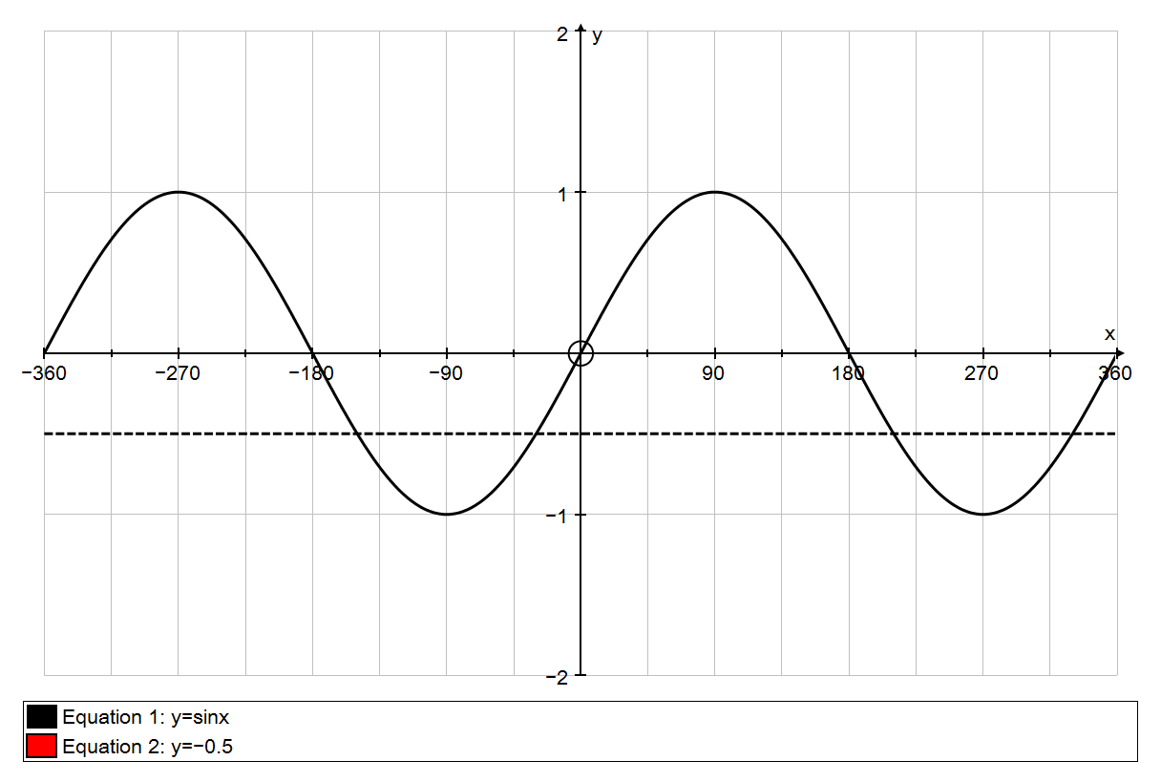

*x* = 210°

*x* = 330°

*x* = –30°

*y* = sin *x*

*y* = –0.5

(The red arrows each indicate 30° to one side or the other.)

Hence the required solutions are 210° or 330°.

***Method 2:*** Use an algebraic rule.

To find the second solution you use sin (180 – *x*)° = sin *x*°

tan (180 + *x*)° = tan *x*°

cos (360 – *x*)° = cos *x*°.

Any further solutions are obtained by adding or subtracting 360 from the principal value or the second solution.

In this example the principal solution is –30°.

Therefore, as this equation involves sine, the second solution is:

180 – (–30)° = 210°

–30° is not in the required range, so add 360 to get:

360 + (–30) = 330°.

Hence the required solutions are 210° or 330°.

You should decide which method you prefer. The corresponding graphs for cos *x* and tan *x* are shown below.

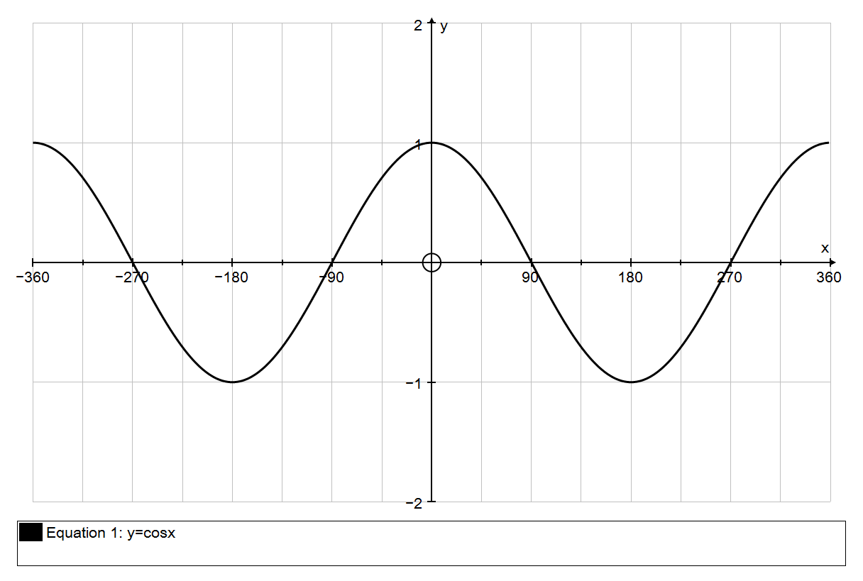

*y* = cos *x*

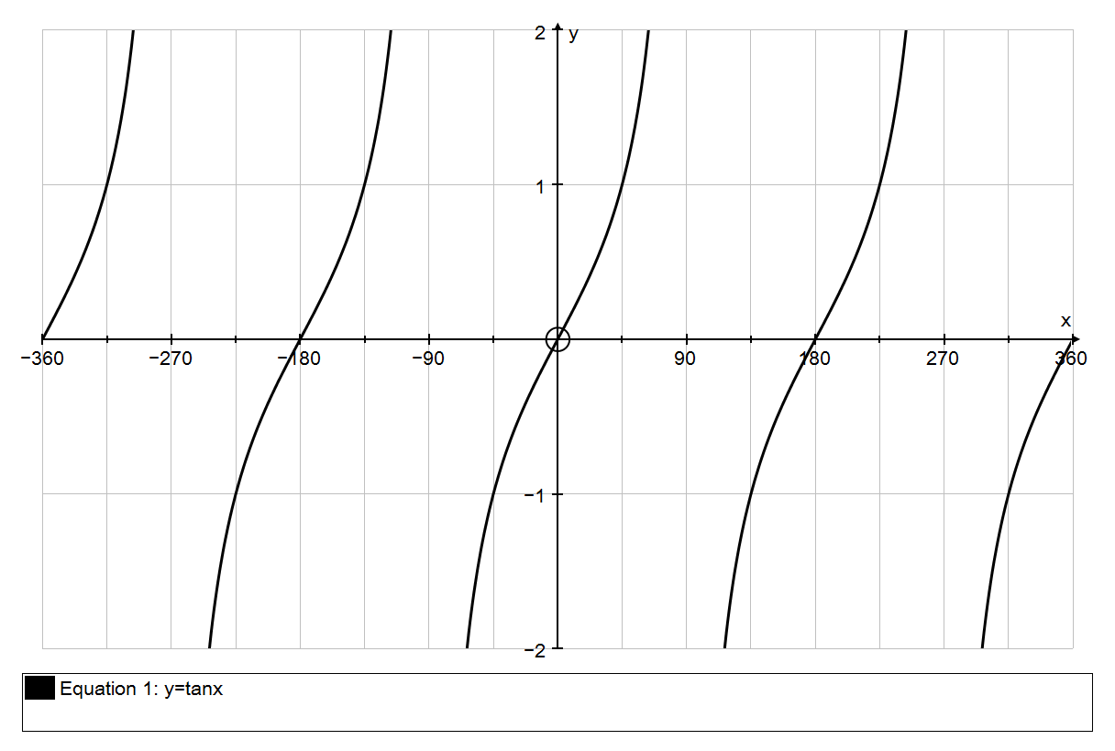

*y* = tan *x*

To solve equations of the form *y* = sin (*kx*), you will expect to get 2*k* solutions in any interval of 360°. You can think of compressing the graphs, or of using a wider initial range.

***Example 2*** Solve the equation sin 3*x*° = 0.5 for 0 ≤ *x* < 360.

***Solution Method 1:*** Use the graph.

The graph of *y* = sin 3*x*° is the same as the graph of *y* = sin *x*° but compressed by a factor of 3 (the *period* is 120°).

The calculator gives sin–1(0.5) = 30, so the principal solution is given by

3*x* = 30 ⇒ *x* = 10.

The vertical lines on the graph below are at multiples of 60°. So you can see from the graph that the other solutions are 50°, 130°, 170°, 250° and 290°.

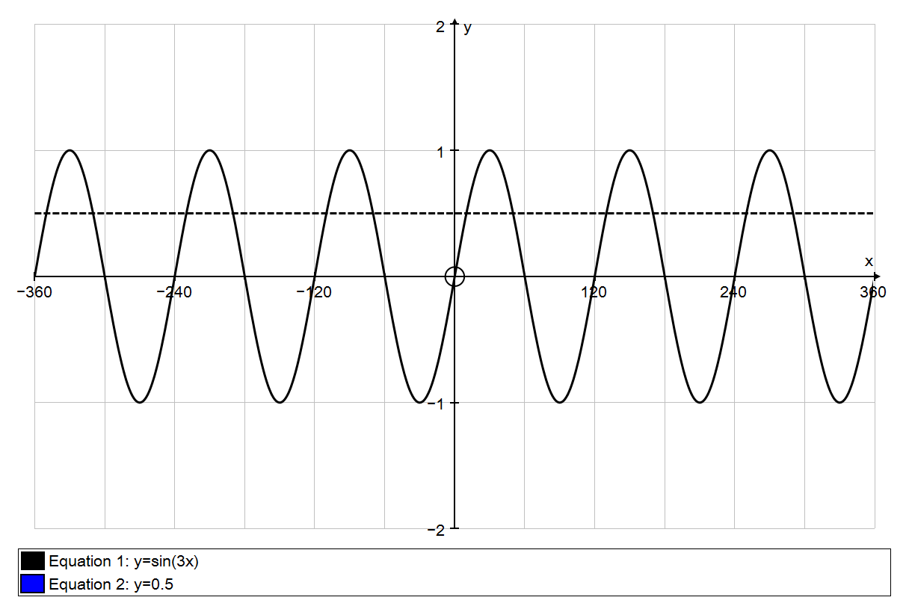

*y* = 0.5

*y* = sin 3*x*

***Method 2:*** The principal value of 3*x* is sin–1(0.5) = 30°.

Therefore 3*x* = 30 or 180 – 30 = 150,

or 360 + 30 or 360 + 150

or 720 + 30 or 720 + 150

⇒ 3*x* = 30, 150, 390, 510, 750, 870

⇒ *x* = 10, 50, 130, 170, 250, 290.

Notice that with Method 2 you have to look at values of 3*x* in the range 0 to 1080 (= 3 × 360), which is somewhat non-intuitive.

### Exercise 2.1

**1** Solve the following equations for 0 ≤ *x* < 360. Give your answers to the nearest 0.1°.

(a) sin *x*°= 0.9 (b) cos *x*°= 0.6 (c) tan *x*°= 2

(d) sin *x*°= –0.4 (e) cos *x*° = –0.5 (f) tan *x*° = –3

**2** Solve the following equations for –180 ≤ *x* < 180. Give your answers to the nearest 0.1°.

(a) sin *x*°= 0.9 (b) cos *x*°= 0.6 (c) tan *x*°= 2

(d) sin *x*°= –0.4 (e) cos *x*° = –0.5 (f) tan *x*°= –3

**3** Solve the following equations for 0 ≤ *x* < 360. Give your answers to the nearest 0.1°.

(a) sin 2*x*° = 0.829 (b) cos 3*x*° = 0.454 (c) tan 4*x* = 2.05

(d)  (e)  (f) 

### 2.2 Other Trigonometric Methods

Suppose that you are told that sin *x*° is exactly . Assuming that *x* is between 0° and 90°, you can find the exact values of cos *x*° and tan *x*° by drawing a right-angled triangle in which the opposite side and the hypotenuse are 2 and 3 respectively:

*x*

3

2

Now Pythagoras’s Theorem tells you that the third, adjacent, side is .

Hence cos *x*° =  and tan *x*° = .

This is preferable to using a calculator as the calculator does not always give exact values for this type of calculation. (Calculators can *in general* not handle irrational numbers exactly, although many are programmed to do so in simple cases.)

A further skill is being able to write down the lengths of the opposite and adjacent sides quickly when you know the hypotenuse. Some students like to do this using the sine rule, but it is not advisable to rely on the sine rule, especially in the mechanics section of A Level mathematics.

***Example 1*** Find the lengths of the opposite and adjacent sides in this triangle.

38°

12 cm

***Solution*** Call the opposite and adjacent sides *y* and *x* respectively. Then

sin 38° = so *y* = 12 sin 38° = 7.39 cm (3 sf).

cos 38° = so *x* = 12 cos 38° = 9.46 cm (3 sf).

It should become almost automatic that the *opposite* side is (hypotenuse) × sin (angle)

and that the *adjacent* side is (hypotenuse) × cos (angle).

If you always have to work these out slowly you will find your progress, in mechanics in particular, is hindered.

### Exercise 2.2

**Do not use a calculator in this exercise.**

**1** In this question *θ* is in the range 0 ≤ *θ* < 90.

(a) Given that , find the exact values of cos *θ* and tan *θ*.

(b) Given that , find the exact values of sin *θ* and cos *θ*.

(c) Given that , find the exact values of sin *θ* and tan *θ*.

**2** Find expressions, of the form *a* sin *θ* or *b* cos *θ*, for the sides labelled with letters in these triangles.

32°

*s*

*r*

5.6 cm

(a) (b)

20 cm

26°

*q*

*p*

10 cm

17°

*u*

*t*

(c) (d)

8.4 cm

20°

*v*

*w*

# 3 Graphs

No doubt you will have *plotted* many graphs of functions such as *y* = *x*2 – 3*x* + 4 by working out the coordinates of points and plotting them on graph paper. But it is actually much more useful for A Level mathematics (and beyond) to be able to *sketch* the graph of a function. It might sound less challenging to be asked to draw a rough sketch than to plot an accurate graph, but in fact the opposite is true. The point is that in order to draw a quick sketch you have to understand the basic shape and some simple features of the graph, whereas to plot a graph you need very little understanding. Many professional mathematicians do much of their basic thinking in terms of shapes of graphs, and you will be more in control of your work, and understand it better, if you can do this too.

When you sketch a graph you are *not* looking for exact coordinates or scales. You are simply conveying the essential features:

* the basic shape
* where the graph hits the axes
* what happens towards the edges of your graph

The actual *scale* of the graph is irrelevant. For instance, it doesn’t matter what the *y*-coordinates are.

### 3.1 Straight line graphs

I am sure that you are very familiar with the equation of a straight line in the form *y* = *mx* + *c*, and you have probably practised converting to and from the forms

*ax* + *by* + *k* = 0 or *ax* + *by* = *k*,

usually with *a*, *b* and *k* are integers. You need to be fluent in moving from one form to the other. The first step is usually to get rid of fractions by multiplying both sides by a common denominator.

***Example 1*** Write  in the form *ax* + *by* + *k* = 0, where *a*, *b* and *k* are integers.

***Solution*** Multiply both sides by 5: 5*y* = 3*x* – 10

Subtract 5*y* from both sides: 0 = 3*x* – 5*y* – 10

or 3*x* – 5*y* – 10 = 0

In the first line it is a very common mistake to forget to multiply the 2 by 5.

It is a bit easier to get everything on the right instead of on the left of the equals sign, and this reduces the risk of making sign errors.

In plotting or sketching lines whose equations are written in the form *ax* + *by* = *k*, it is useful to use the *cover-up rule*:

***Example 2*** Draw the graph of 3*x* + 4*y* = 24.

***Solution*** Put your finger over the “3*x*”. You see “4*y* = 24”.

This means that the line hits the *y*-axis at (0, 6).

Repeat for the “4*y*”. You see “3*x* = 24”.

(0, 6)

(8, 0)

*y*

*x*

This means that the line hits the *x*-axis at (8, 0).

[NB: *not* the point (8, 6)!]

Mark these points in on the axes.

You can now draw the graph.

**Exercise 3.1**

**1** Rearrange the following in the form *ax* + *by* + *c* = 0 or *ax* + *by* = *c* as convenient, where *a*, *b* and *c* are integers and *a* > 0.

(a) *y* = 3*x* – 2 (b) 

(c)  (d) 

(e)  (f) 

**2** Rearrange the following in the form *y* = *mx* + *c*. Hence find the gradient and the *y*-intercept of each line.

(a) 2*x* + *y* = 8 (b) 4*x* – *y* + 9 = 0

(c) *x* + 5*y* = 10 (d) *x* – 3*y* = 15

(e) 2*x* + 3*y* + 12 = 0 (f) 5*x* – 2*y* = 20

(g) 3*x* + 5*y* = 17 (h) 7*x* – 4*y* + 18 = 0

**3** Sketch the following lines. Show on your sketches the coordinates of the intercepts of each line with the *x*-axis and with the *y*-axis.

(a) 2*x* + *y* = 8 (b) *x* + 5*y* = 10

(c) 2*x* + 3*y* = 12 (d) 3*x* + 5*y* = 30

(e) 3*x* – 2*y* = 12 (f) 4*x* + 5*y* + 20 = 0

### 3.2 Basic shapes of curved graphs

You need to know the names of standard types of expressions, and the graphs associated with them.

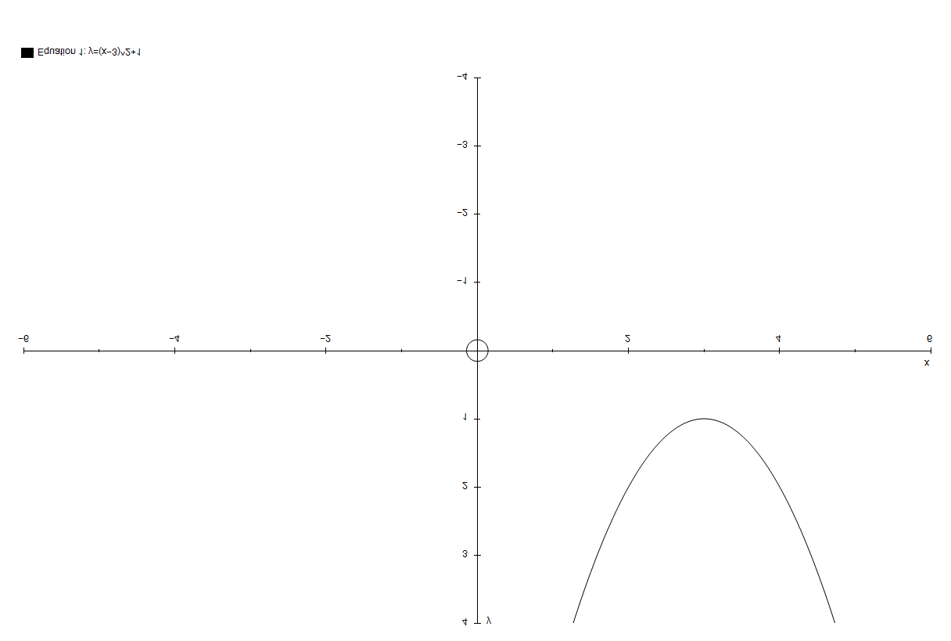(a) The graph of a **quadratic** function (e.g. *y* = 2*x*2 + 3*x* + 4) is a ***parabola:***

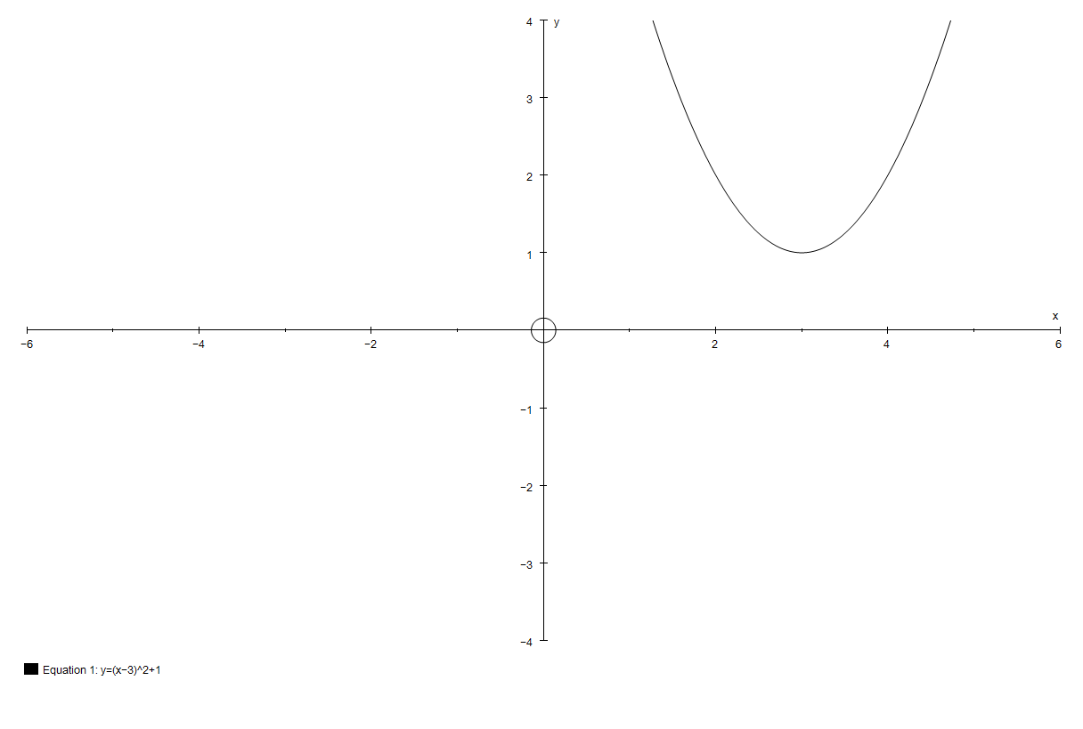

***Notes:***

* Parabolas are symmetric about a vertical line.
* They are not U-shaped, so the sides never reach the vertical. Neither do they dip outwards at the ends.

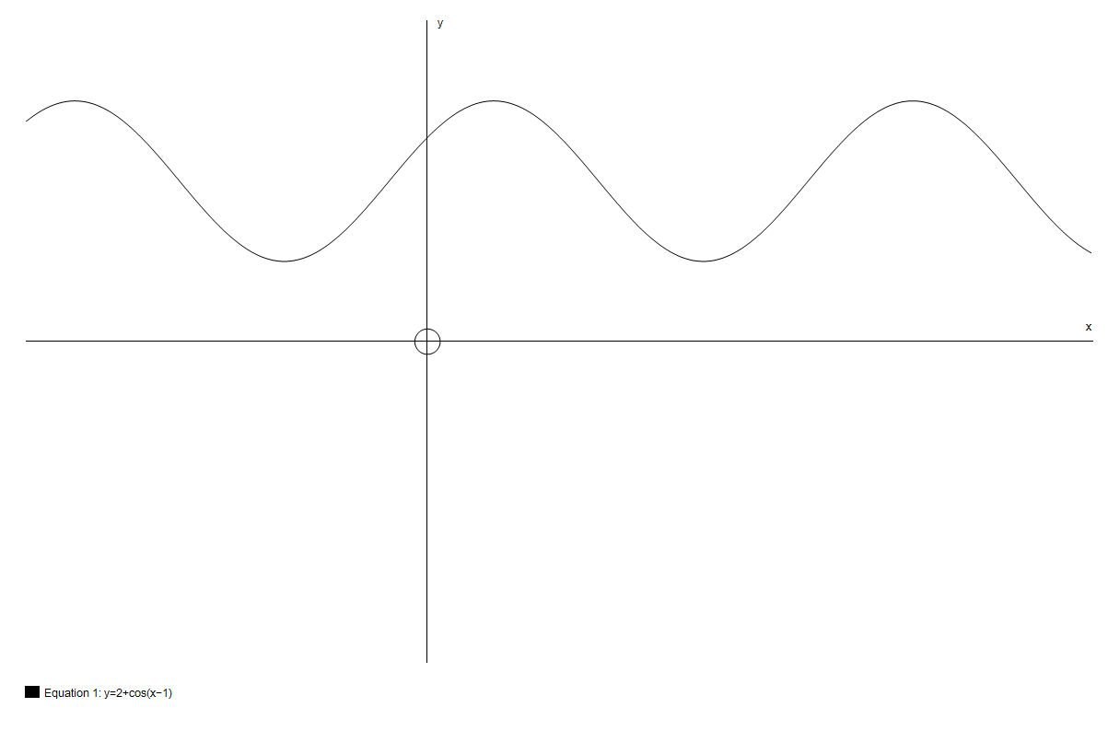

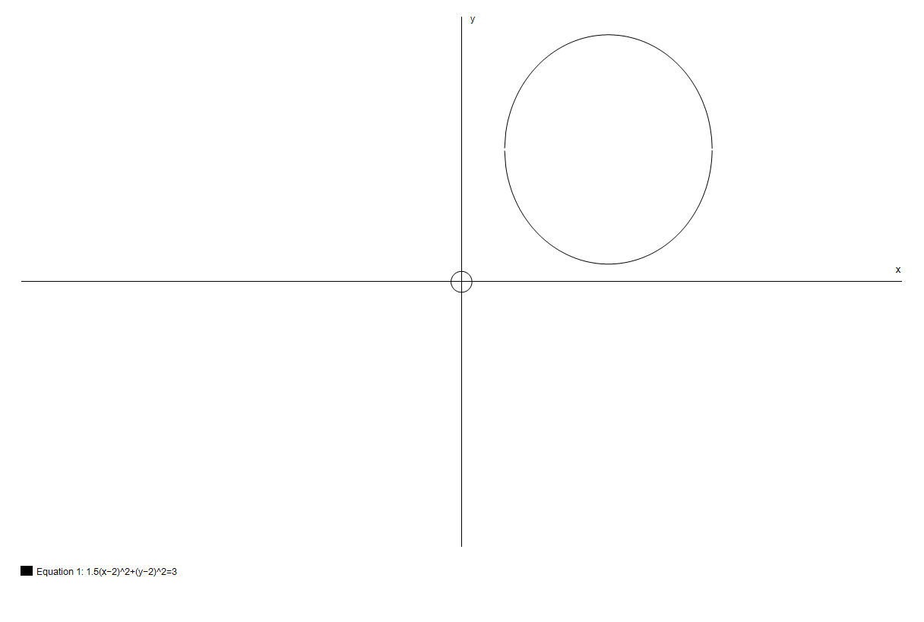These are wrong:

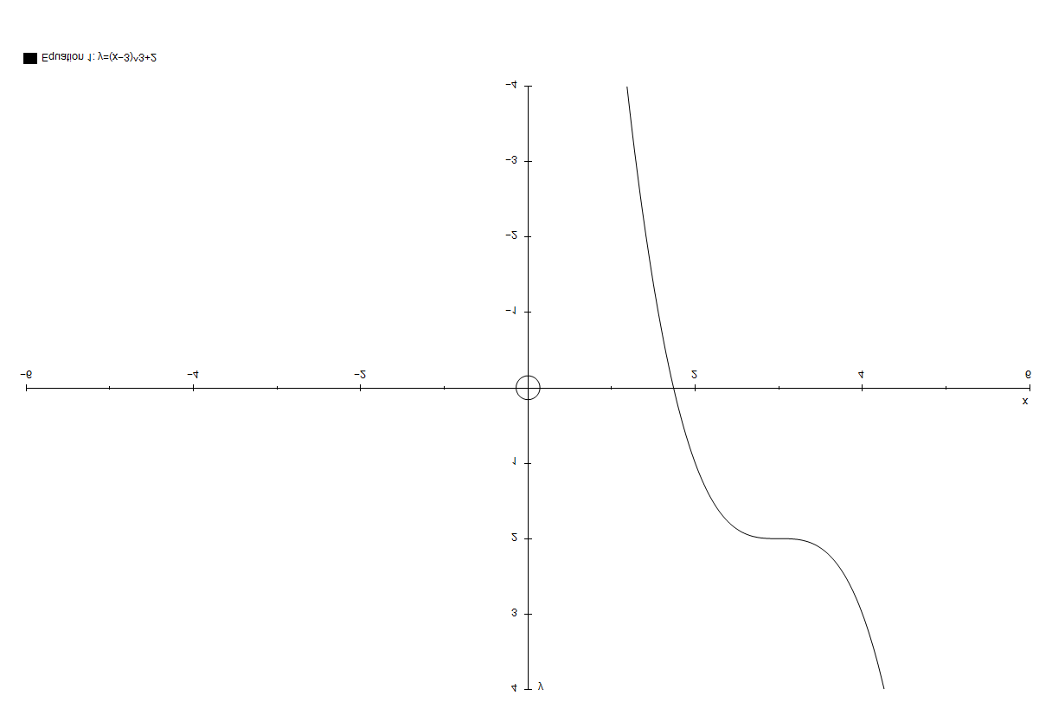(b) The graph of a **cubic** function (e.g. *y* = 2*x*3 – 3*x*2 + 4*x* – 5) has no particular name; it’s usually referred to simply as a **cubic graph**. It can take several possible shapes:

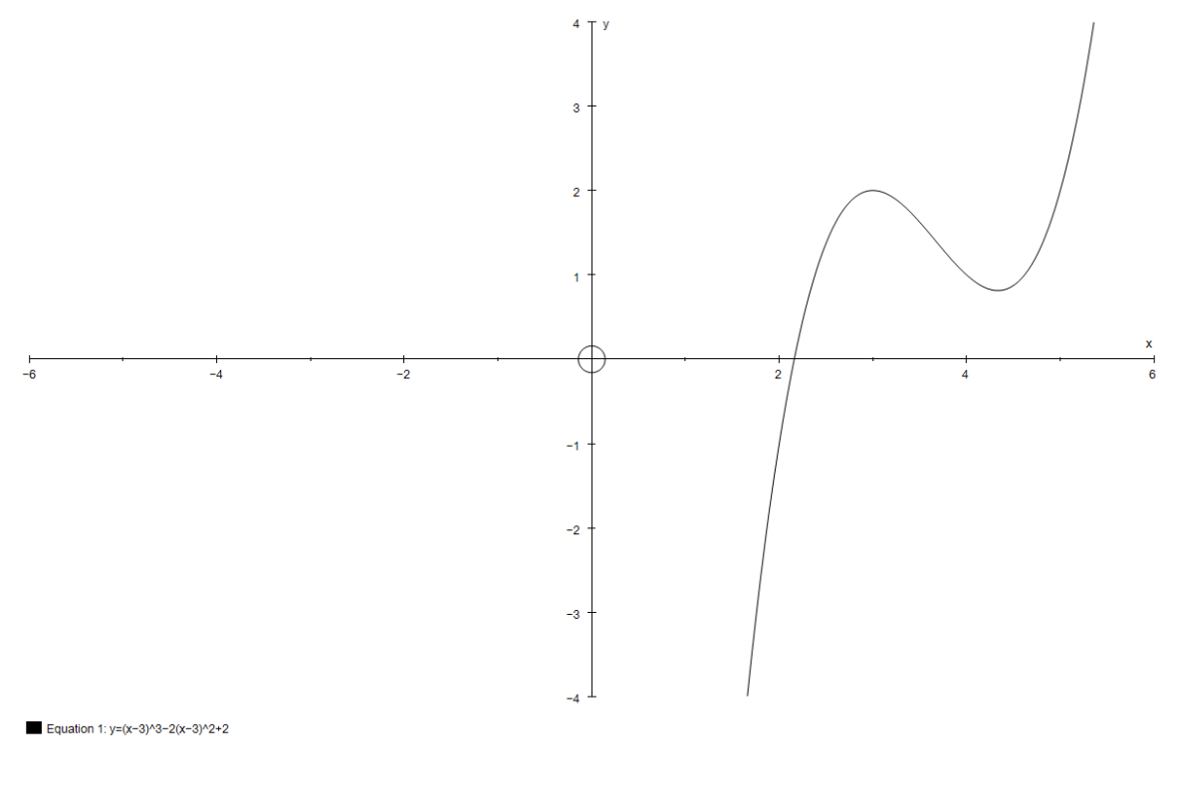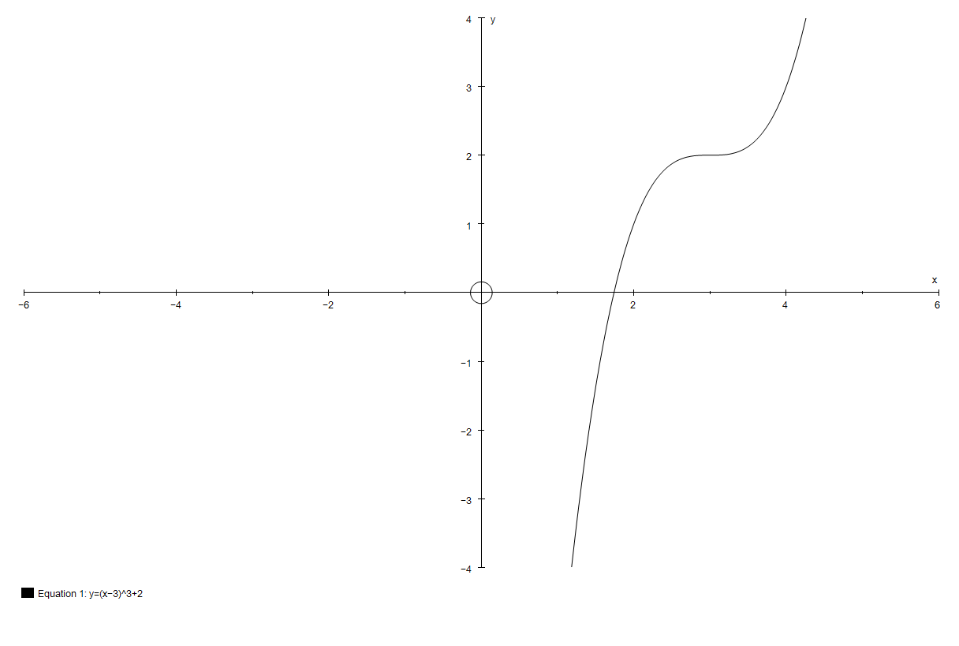

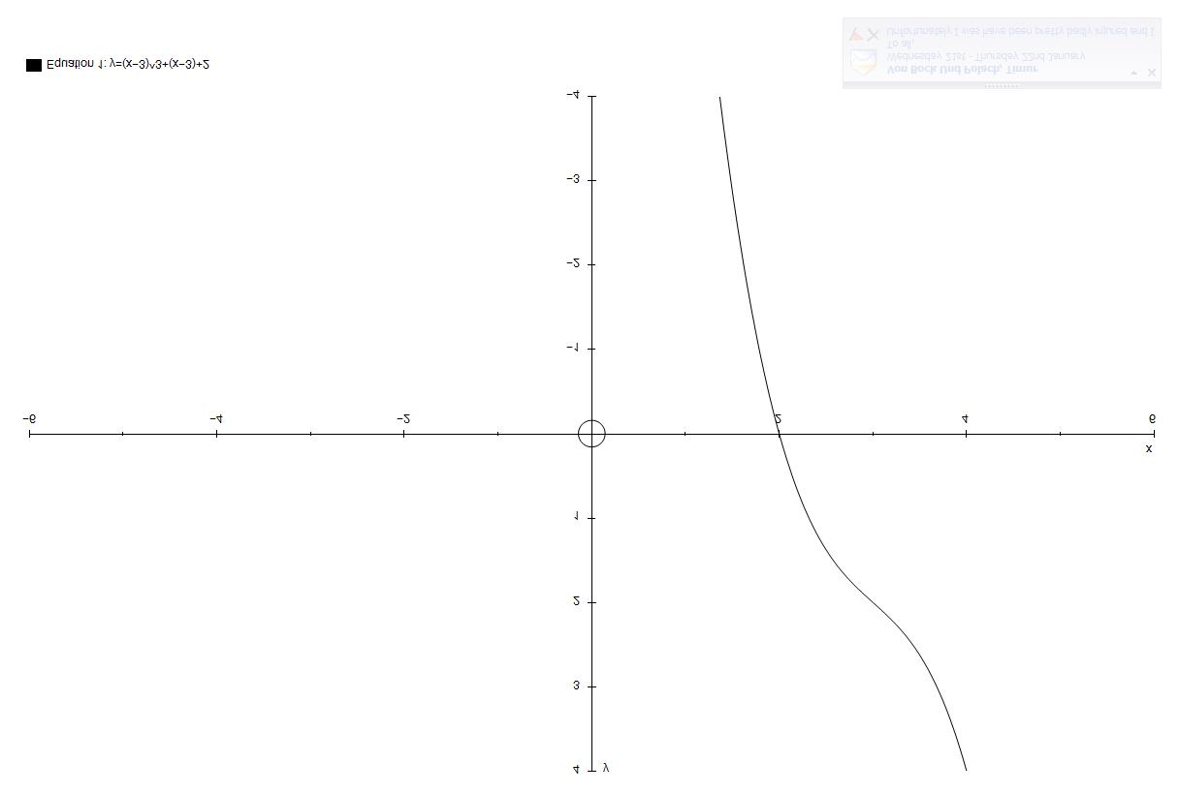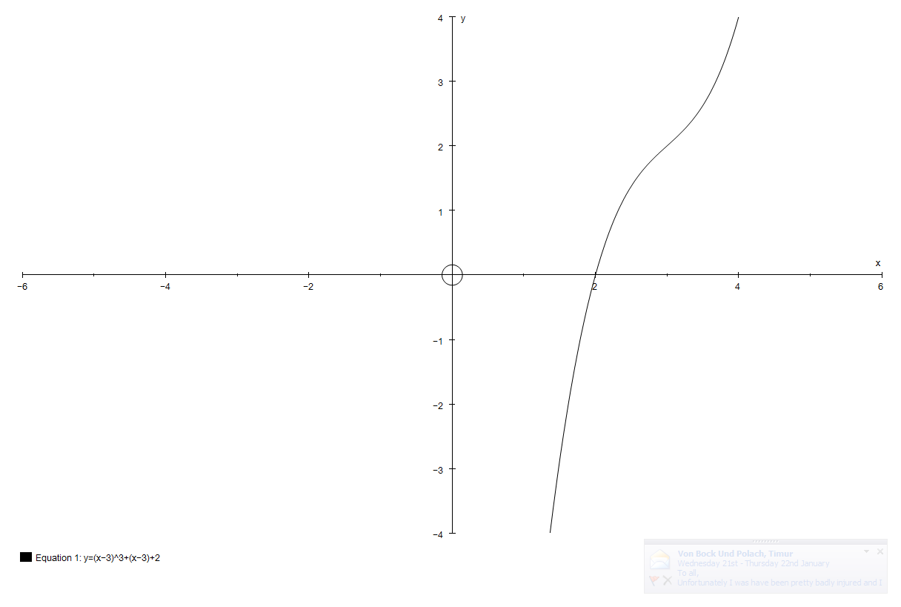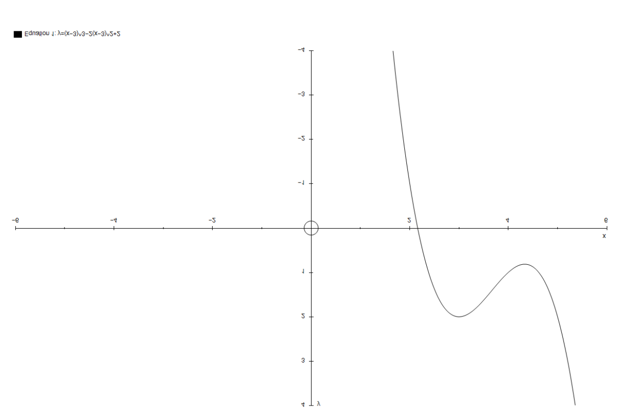

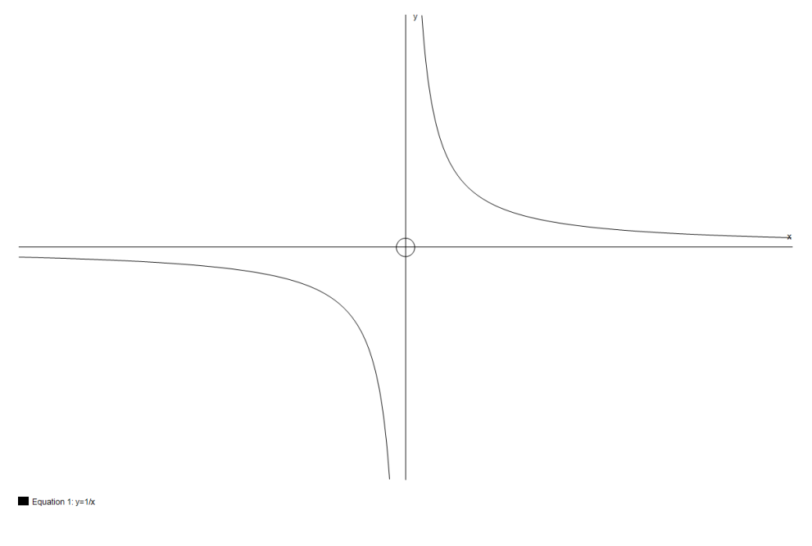(c) The graph of  is a ***hyperbola***:

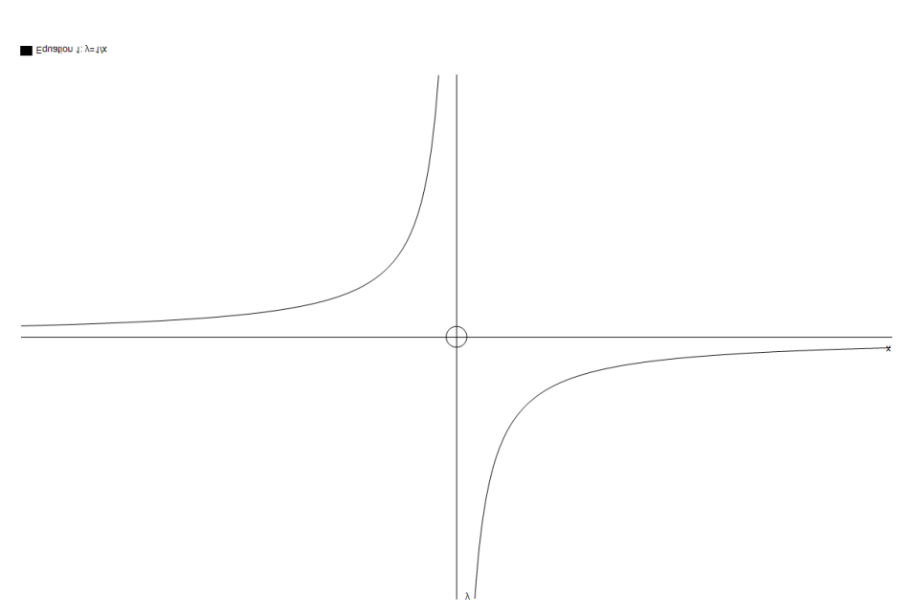

The graph of a hyperbola gets closer and closer to the axes without ever actually touching them. This is called **asymptotic** behaviour, and the axes are referred to as the **asymptotes** of this graph.

(d) The graph of  is similar (but not identical) to a hyperbola to the right but is in a different quadrant to the left:

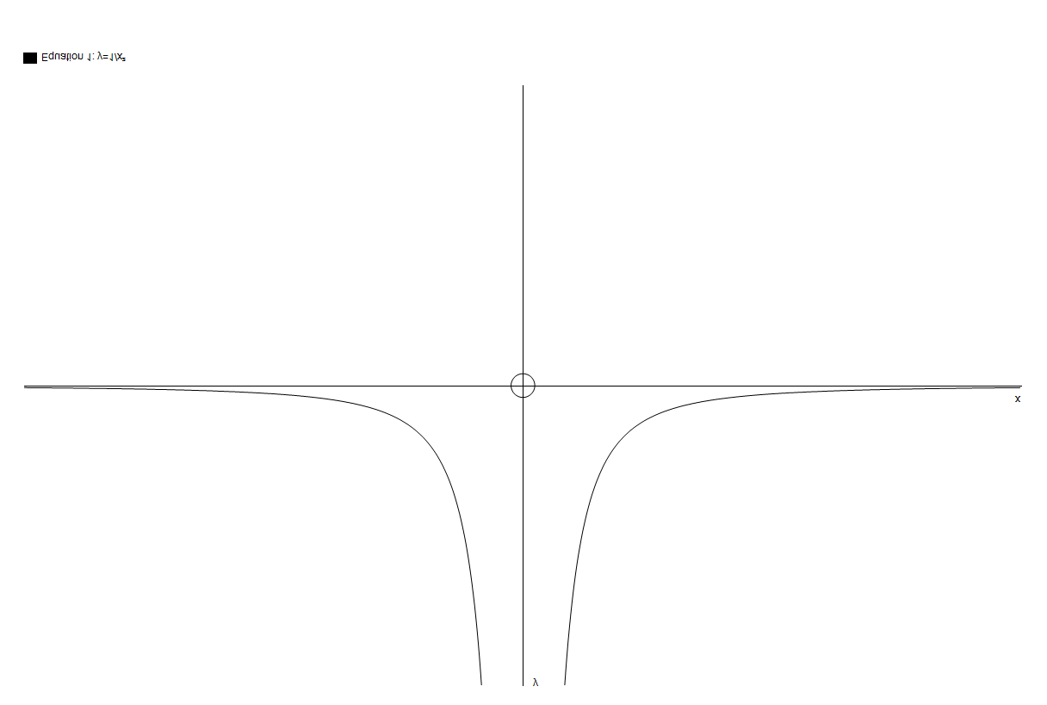

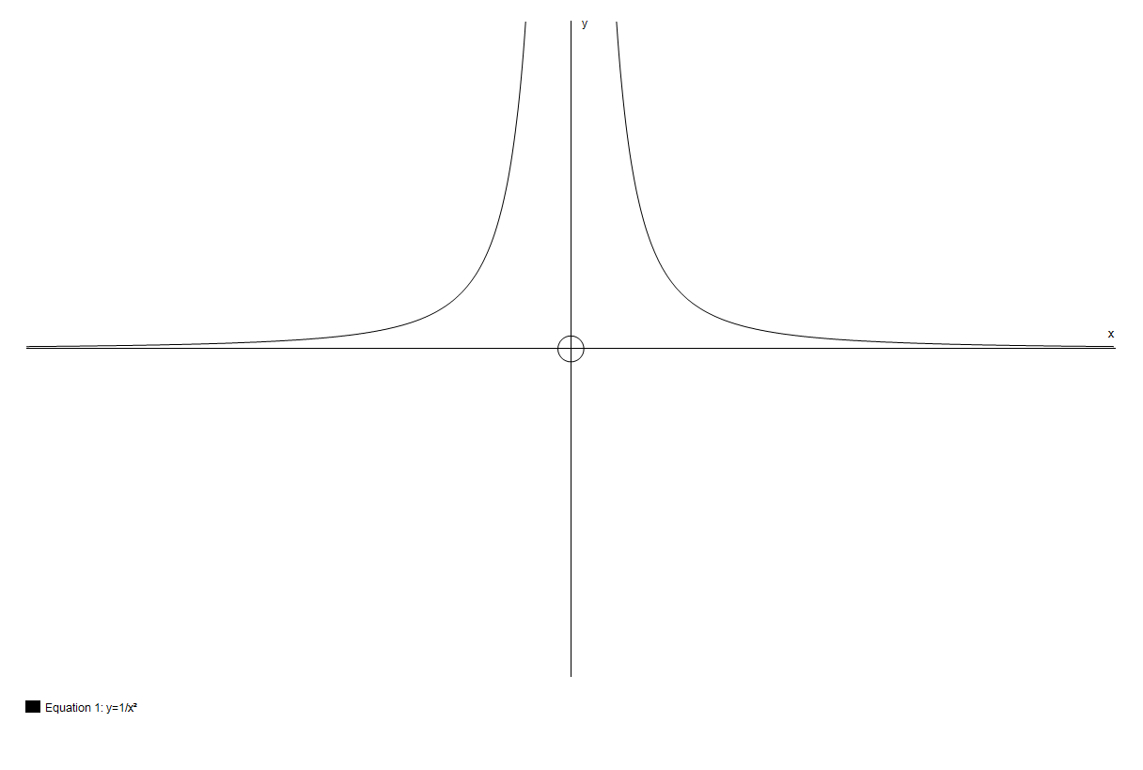

(e) Graphs of higher *even* powers (f) Graphs of higher *odd* powers

*y* = *x*4 (*y* = *x*6 etc. are similar): *y* = *x*5 (*y* = *x*7 etc. are similar):

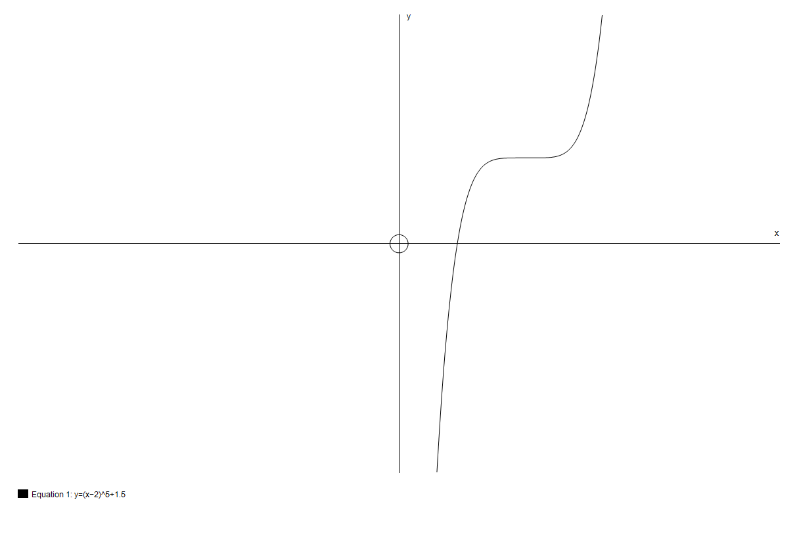

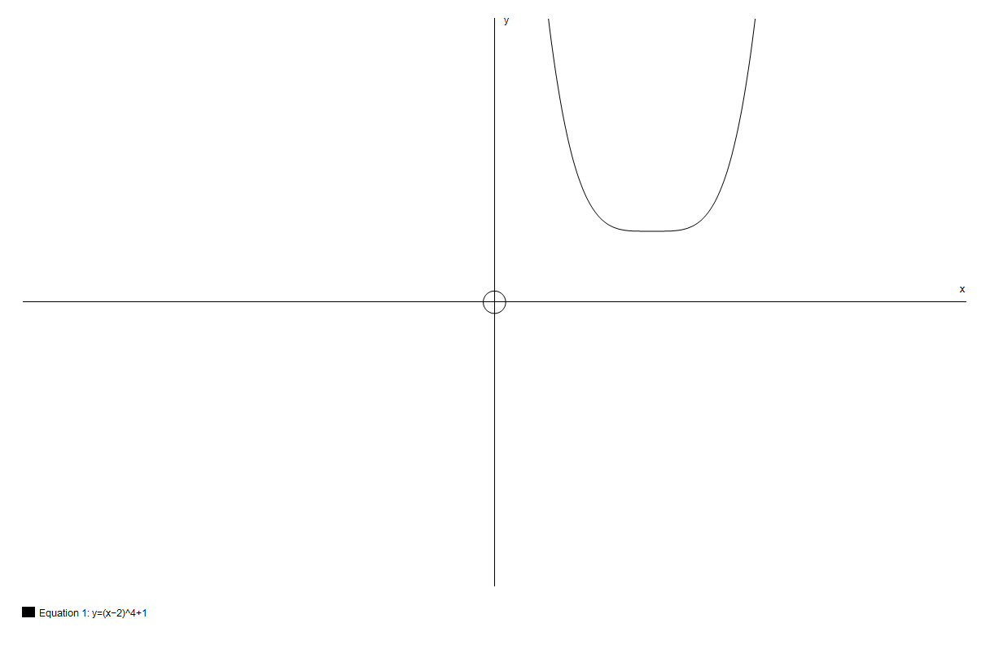 **Which way up?** This is determined by the *sign of the highest power*.

If the sign is positive, the *right-hand* side is (eventually) *above the x-axis.*

This is because for big values of *x* the highest power dominates the expression*.*

(If *x* = 1000, *x*3 is bigger than 50*x*2).

***Examples*** *y* = *x*2 – 3*x* – 1 *y* = 10 – *x*2





These are often referred to (informally!) as ***happy*** and ***sad*** parabolas respectively ☺ ☹ .

*y* = *x*3 – 3*x* – 2 *y* = 2 – *x* – *x*5

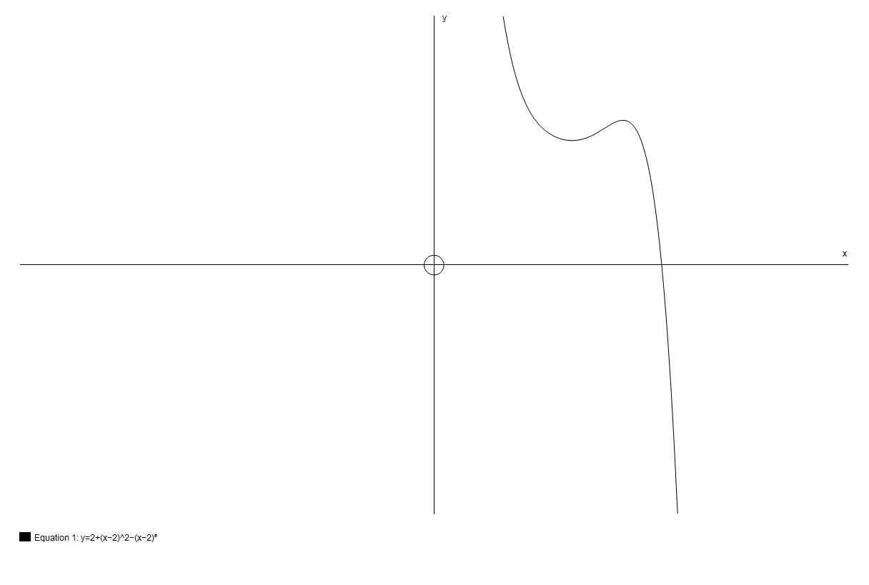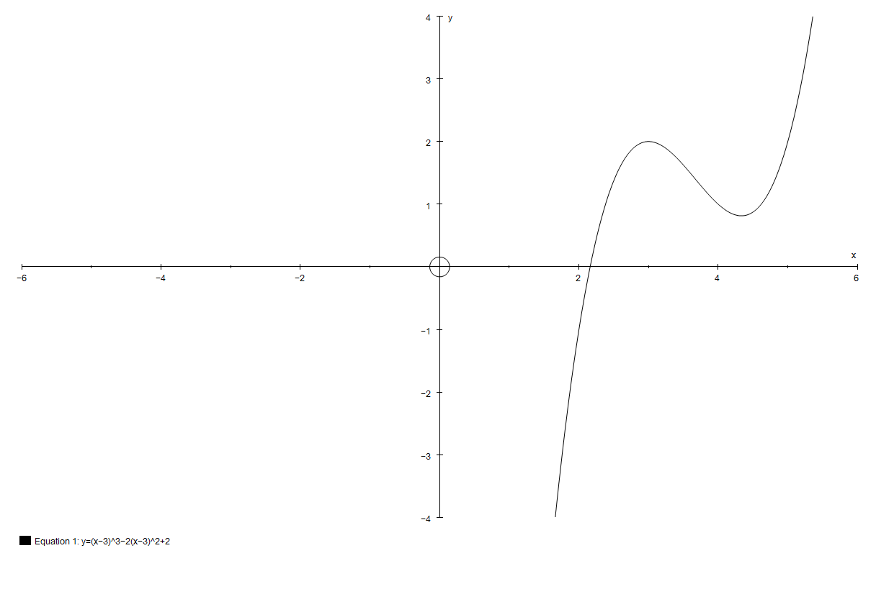

### Exercise 3.2

Sketch (do not *plot*) the general shape of the graphs of the following curves.

Axes are not required but can be included in the questions marked with an asterix.

**1** *y* = *x*2 – 3*x* + 2 **2** *y* = –*x*2 + 5*x* + 1

**3** *y* = 1 – *x*2 **4** *y* = (*x* – 2)(*x* + 4)

**5** *y* = (3 – *x*)(2 + *x*) **6** *y* = (1 – *x*)(5 – *x*)

**7** *y* = *x*3 **8** *y* = –*x*3

**9\***  **10\*** 

**11** *y* = (*x* – 2)(*x* – 3)(*x* + 1) **12\*** 

**13** Sketch on the same axes the general shape of the graphs of *y* = *x*2 and *y* = *x*4.

**14** Sketch on the same axes the general shape of the graphs of *y* = *x*3 and *y* = *x*5.

### 3.3 Factors

Factors are crucial when curve-sketching.

They tell you where the curve meets the *x*-axis.

**Do not multiply out brackets!**

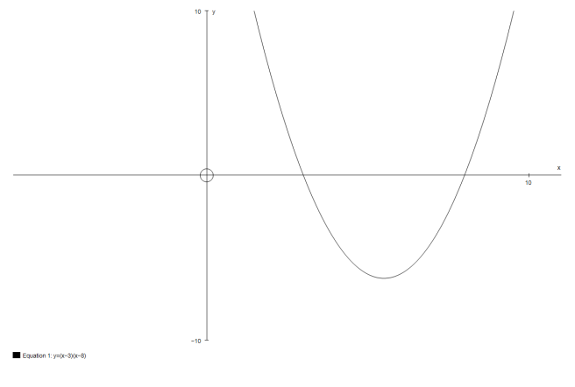***Example*** Sketch the graph of *y* = (*x* – 2)(*x* + 3).

***Solution*** The graph is a *positive* (happy!) *parabola*

so start by drawing the *correct shape*

with a *horizontal axis* across it.



–3 2

The factors tell you that it hits the *x*-axis

at *x* = –3 and *x* = 2.

Mark these on your sketch:

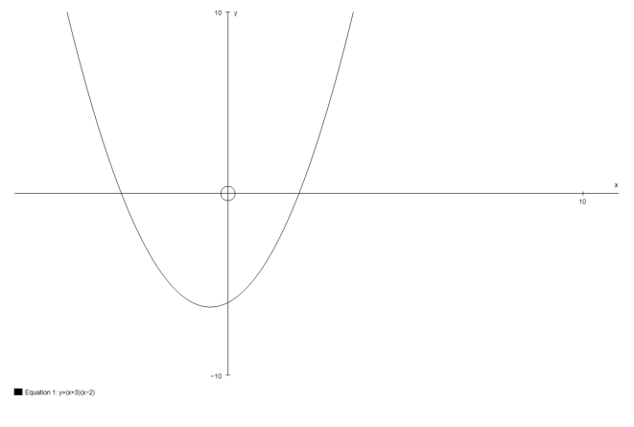

–3 2

and only now put in the *y*-axis, which is

clearly slightly nearer 2 than –3:

***Note:*** the lowest point on the graph is

*not* on the *y*-axis. (Because the

graph is symmetric, it is at *x* = .)

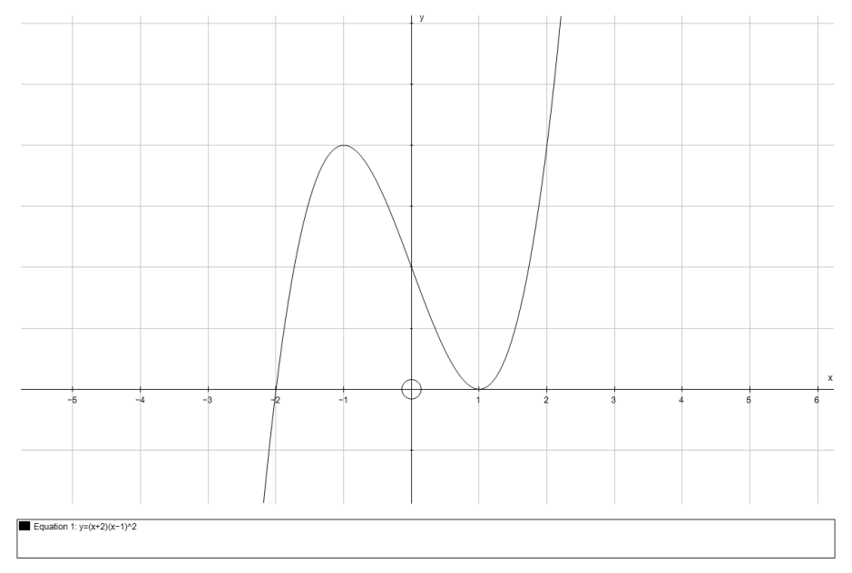**Repeated factors**

Suppose you want to sketch *y* = (*x* – 1)2(*x* + 2).

You know there is an intercept at *x* = –2.

At *x* = 1 the graph *touches* the axes, as if it were

the graph of *y* = (*x* – 1)2 there.

[More precisely, it is very like *y* = 3(*x* – 1)2 there. That is because, close to *x* = 1, the (*x* – 1)2 factor changes rapidly, while (*x* + 2) remains close to 3.]

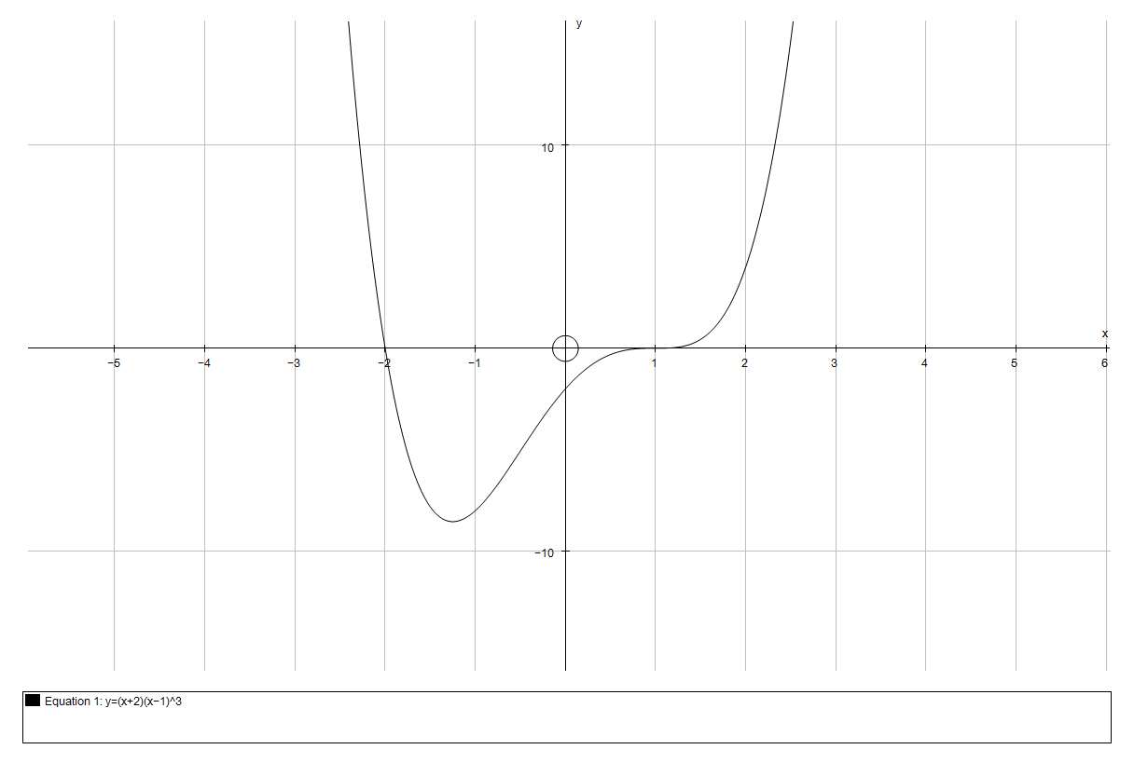

Likewise, the graph of *y* = (*x* + 2)(*x* – 1)3

looks like *y* = (*x* – 1)3 close to *x* = 1.

[Again, more precisely, it is

very like *y =* 3(*x* – 1)3 there.]

### Exercise 3.3

Sketch the curves in questions 1–21. Use a different diagram for each.   
Show the *x*-coordinates of the intersections with the *x*-axis.

**1** *y* = *x*2 **2** *y* = (*x* – 1)(*x* – 3)

**3** *y* = (*x* + 2)(*x* – 4) **4** *y* = *x*(*x* – 3)

**5** *y* = (*x* + 2)(3*x* – 2) **6** *y* = *x*(4*x* + 3)

**7** *y* = –*x*(*x* – 3) **8** *y* = (2 – *x*)(*x* + 1)

**9** *y* = (3 – *x*)(2 + *x*) **10** *y* = (*x* + 2)(*x* – 1)(*x* – 4)

**11** *y* = *x*(*x* – 1)(*x* + 2) **12** *y* = –*x*(*x* – 1)(*x* + 2)

**13** *y* = (3 – *x*)(2 – *x*)(1 – *x*) **14** *y* = (*x* – 1)2(*x* – 3)

**15** *y* = (*x* – 1)(*x* – 3)2 **16** *y* = (*x* + 1)3

**17** *y* = (2 – *x*)(*x* + 1)3 **18** *y* = (*x* + 1)(*x* + 2)(*x* – 1)(*x* – 2)

**19** *y* = –(*x* + 3)(*x* + 2)(*x* – 1)(*x* – 4) **20** *y* = (*x* – 2)2(*x* + 2)2

**21** *y* = (*x* – 1)(*x* – 2)2(*x* – 3)3

**22** (a) Sketch the graph of *y* = *x*2.

(b) Sketch *y* = 2*x*2 on the same axes.

(c) Sketch *y* = *x*2 + 1 on the same axes.

**23** (a) Sketch the graph of *y* = √*x*.

(b) Sketch *y* = 2√*x* on the same axes.

**24** (a) Sketch the graph of .

(b) Sketch  on the same axes.

**25** (a) Sketch the graph of .

(b) Sketch on the same axes.

**26** (a) Sketch the graph of *y* = *x*3.

(b) Sketch *y* = 2*x*3 on the same axes.

**27** (a) Sketch the graph of *y* = *x*4.

(b) Sketch *y* = 3*x*4 on the same axes.

**28** (a) Sketch the graph of *y* = *x*3 – 4*x*.

[Hint: It cuts the *x*-axis at –2, 0 and 2.]

(b) Sketch *y* = 2*x*3 – 8*x* on the same axes.

**29** (a) Sketch the graph of *y* = *x*4 – *x*2.

[Hint: It cuts the *x*-axis at 1 and –1, and touches the axis at 0.]

(b) Sketch *y* = –*x*4 + *x*2 on the same axes.

**30** Sketch, on separate axes, the following graphs. Show the *x*-coordinates of the intersections with the *x*-axis.

(a) *y* = 4 – *x*2

(b) *y* = (*x* – 2)(*x* + 1)

(c) *y* = –(*x* – 2)(*x* + 1)

(d) *y* = *x*(*x* + 4)

(e) *y* = (*x* – 2)2

(f) *y* = –(*x* + 1)2

(g) *y* = (1 – *x*)(2 + *x*)

# Further reading

There are not many books designed for the sort of transition that this booklet represents, but an outstanding exception is:

Fyfe, M. T., Jobbings, A. and Kilday, K. (2007) *Progress to Higher Mathematics*, Arbelos.

ISBN 9780955547706.

Alternatively, also published by Arbelos is an expansion of the same book which is more specifically aimed at the transition to A Level. You may not need quite so much as this:

Fyfe, M. T., and Kilday, K. (2011) *Progress to Advanced Mathematics*, Arbelos.

ISBN 9780955547737.

# Answers, hints and comments

### 

### Exercise 1.1

**1** (a) *p* = 7 (b) *q* = 5 (c) *r* = 10

**2** (a) *x* = 1 (b) *x* = 5 (c) *x* = –34

**3** 

**4** (a) 2(*x* + 5) (b) 4(*x* + 2) (c) 3(*x* + 7) (d) 2(*x* – 3)

**5** (a) *x* = –4 (b) *x* = 9 (c) 

**6** (a)  (or ) (b)  (or )

### Exercise 1.2

**1** (a)  (b)  (c)  (d) 

(e)  (f)  (g)  (h) 

(i)  (j)  (k)  (l) 

(m)  (n)  (o)  (p) 

**2** (a)  (b)  (c)  (d) 

**3** (a)  (b)  (c) 

**4** (a)  (b)  (c) 

(d)  (e)  (f) 

(g) 

**5** (a)  (b)  (c) 

### Exercise 1.3

**1** (a) *x*2 + 10*x* + 25 (b) *x*2 – 8*x* + 16 (c) 4*x*2 + 4*x* + 1

(d) 9*x*2 – 12*x* + 4 (e) *x*2 – 4 (f) 9*x*2 – 16

**2** (a) *x* + *y* + 2 = 0

(b) 5*x* + 2*y* = 0

(c) *x* + *y* = 0

**3** (a) impossible (b) (*x* – 2) (c) impossible

(d) impossible (e) impossible (f) *x* + *y*

**4** (a) (*x* + 4)2 + 3 (b) (*x* – 5)2 – 2 (c) (*x* + 1)2 – 5

(d) (*x* – 2)2 – 7 (e) (*x* – 1½)2 – ¼ (f) (*x* – 2½)2 – 12¼

**5** (a) 3(*x* + 1)2 + 4 (b) 5(*x* – 2)2 – 3 (c) 2(*x* + 2½)2 + ½

**6** (a) (2*x* + 3)2 + 5 (b) (3*x* – 2)2 – 5 (c) (4*x* + 5)2 – 3

**7** (a) (*x* – 5)(*x* + 5) (b) 4(*x* – 3)(*x* + 3) (c) (2*x* – 3*y*2)(2*x* + 3*y*2)

(d) (3*x* – 1)(*x* – 2) (e) (3*x* – 2)(*x* – 1) (f) (3*x* + 2)(2*x* – 3)

(g) (4*x* + 5)(2*x* – 3)

**8** (a)  (b)  (c) 

### 

### Exercise 1.4

**1** (a) 12*x* (b) 4*x*2

(c) 2 + 3*x* (d) 12*x*

(e) 3*xy* (f) 

(g) can’t be simplified (h) 

(i) can’t be simplified (j) –1

**2** (a)  (b) 

**3** (a)  (b) 

**4** (a)  (b) 

(c)  (d) 

(e) 

### Exercise 1.5

The answer to the question “why not?” in example 1 (page 16) is that *x*2 + *y*2 has no simple square root. In particular it is not *x* + *y*. [Remember that (*x* + *y*)2 = *x*2 + 2*xy* + *y*2.]

**1** (2, 4), (3, 1) **2** (6, –3), (7, 0)

**3** (1, –1), (–1, 0) **4** (1, 2), (–1, –2)

### Exercise 1.6

**1** (a) *x*–1 (b) *x*–5 (c) *x*1/5 (d) *x*3/5 (e) *x*–1/2 (f) *x*–1/3

**2** (a)  (b) 1 (c)  (d)  (e) 

**3** (a) 4*x*1/3 (b) 3*x*–2 (c) 5*x*–1/2 (d) ½*x*–3 (e) 6*x*0

**4** (a) *x*4 + *x*2 (b) *x*2 + *x*–2 (c) *x*–4 + *x*–7

**5** (a) 5√3 (b) 6√5 (c) 2√6 (d)  (e) 

**6** (a) √2 + 1 (b) √6 + 2 (c) 2(√7 – 2) (d)  (e) √6 + √5

### Exercise 2.1

**1** (a) 64.2, 115.8 (b) 53.1, 306.9 (c) 63.4, 243.4

(d) 203.6, 336.4 (e) 120, 240 (f) 108.4, 288.4

**2** (a) 64.2, 115.8 (b) 53.1, –53.1 (c) 63.4, –116.6

(d) –23.6, –156.4 (e) 120, –120 (f) –71.5, 108.4

**3** (a) *p* = 20 sin 26°, *q* = 20 cos 26° (b) *r* = 5.6 sin 32°, *s* = 5.6 cos 32°

(c) *t* = 10 sin 17°, *u* = 10 cos 17° (d) *v* = 8.4 cos 20°, *w* = 8.4 sin 20°

### Exercise 3.1

**1** (a) *y* = –2*x* + 8; –2, 8 (b) *y* = 4*x* + 9; 4, 9

(c) ; , 2 (d) ; , –5

(e) ; , –4 (f) ; , –10

(g) ; ,  (h) ; , 

**2** (a)(b)

*y*

*x*

8

4

*y*

*x*

2

10

(c) (d)

*y*

*x*

6

4

*y*

*x*

6

10

(e) (f)

*y*

*x*

–6

4

*x*

*y*

–5

–4

### Exercise 3.2

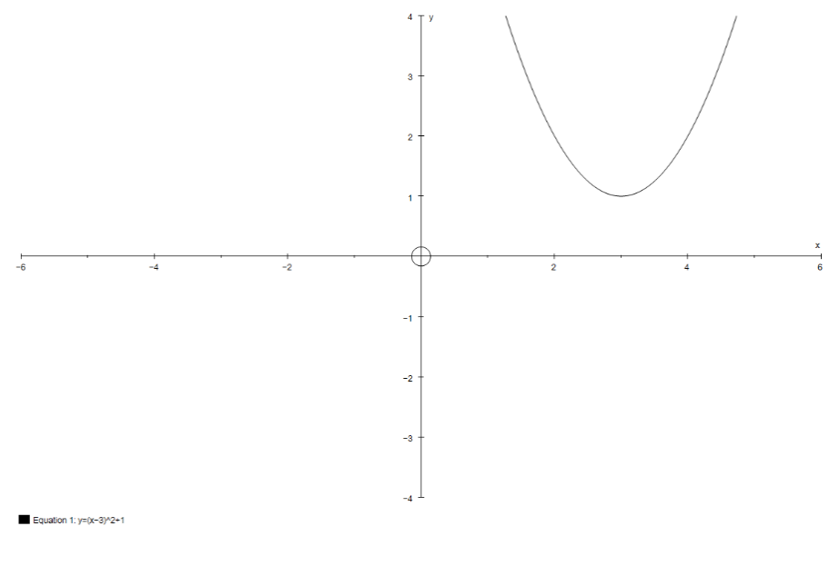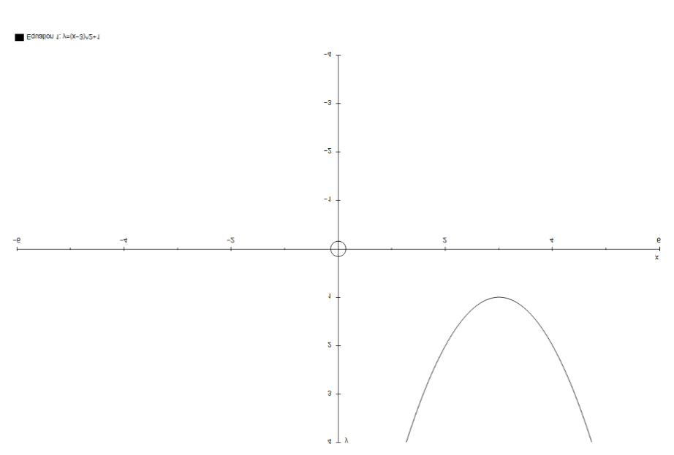

**1 2**



**3 4**



**5 6**

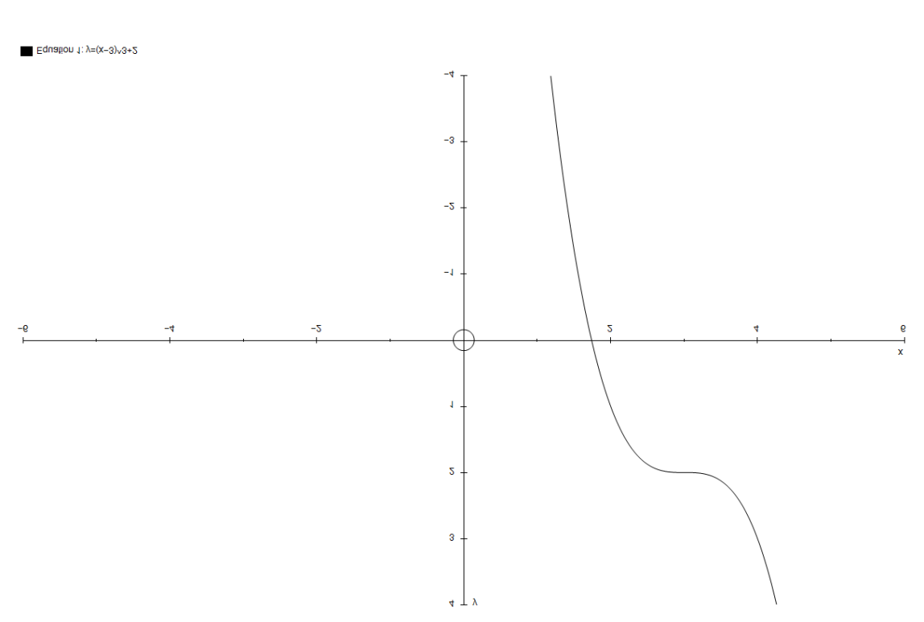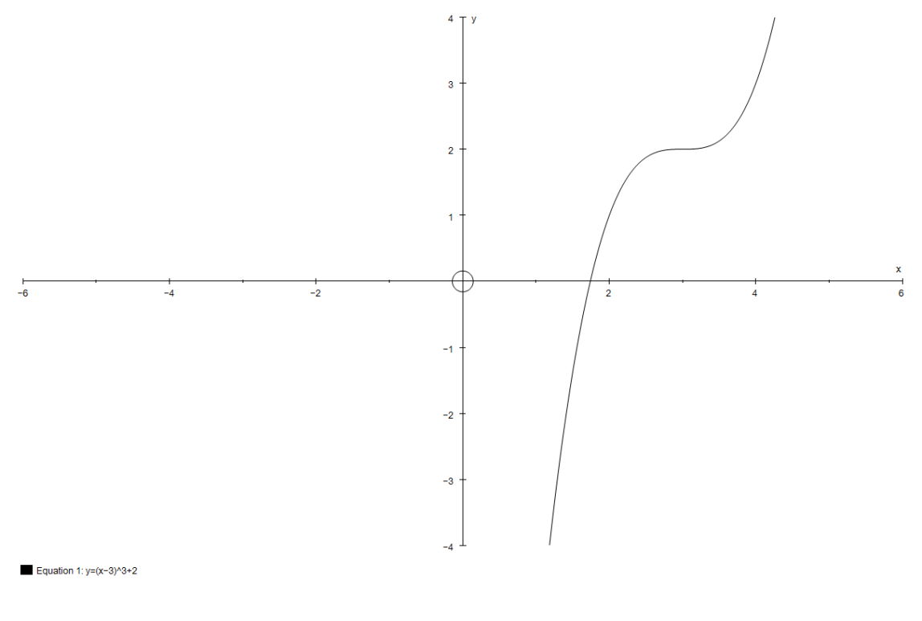

**7 8**

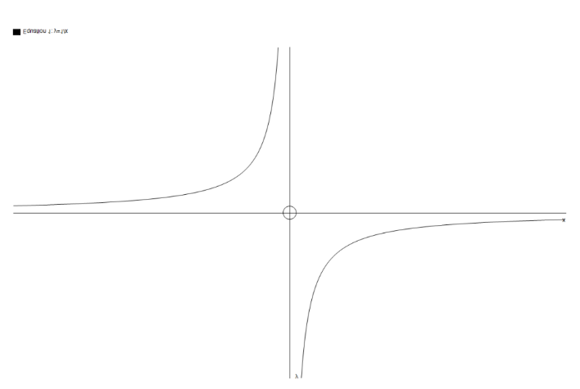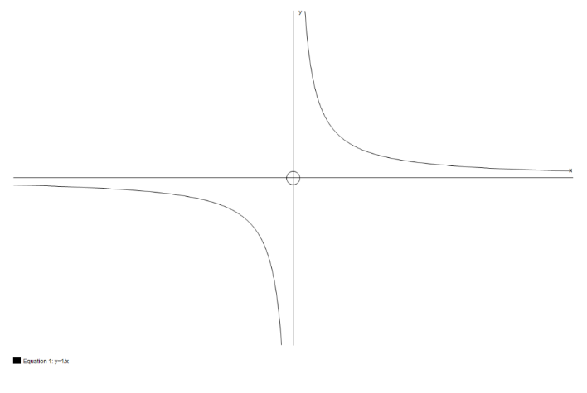**9 10**

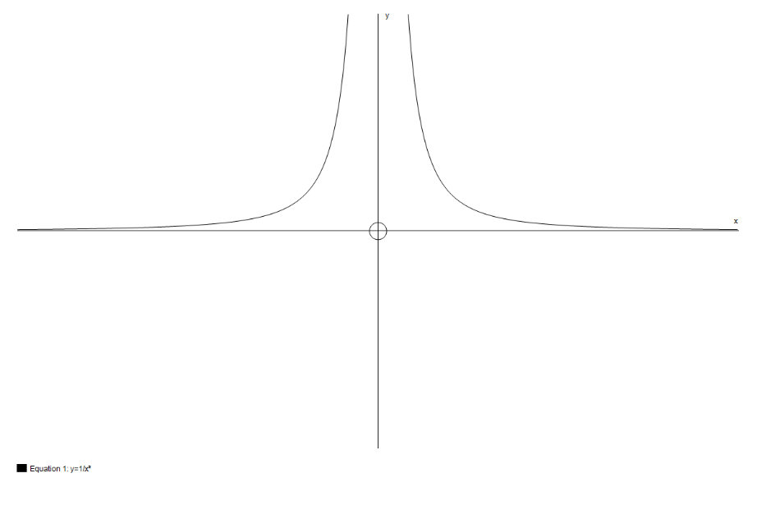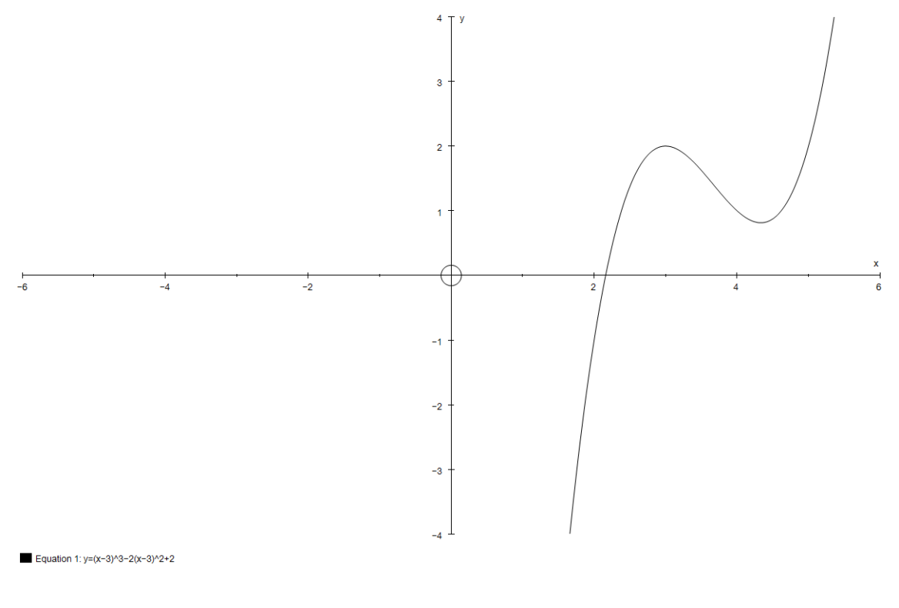**11 12**

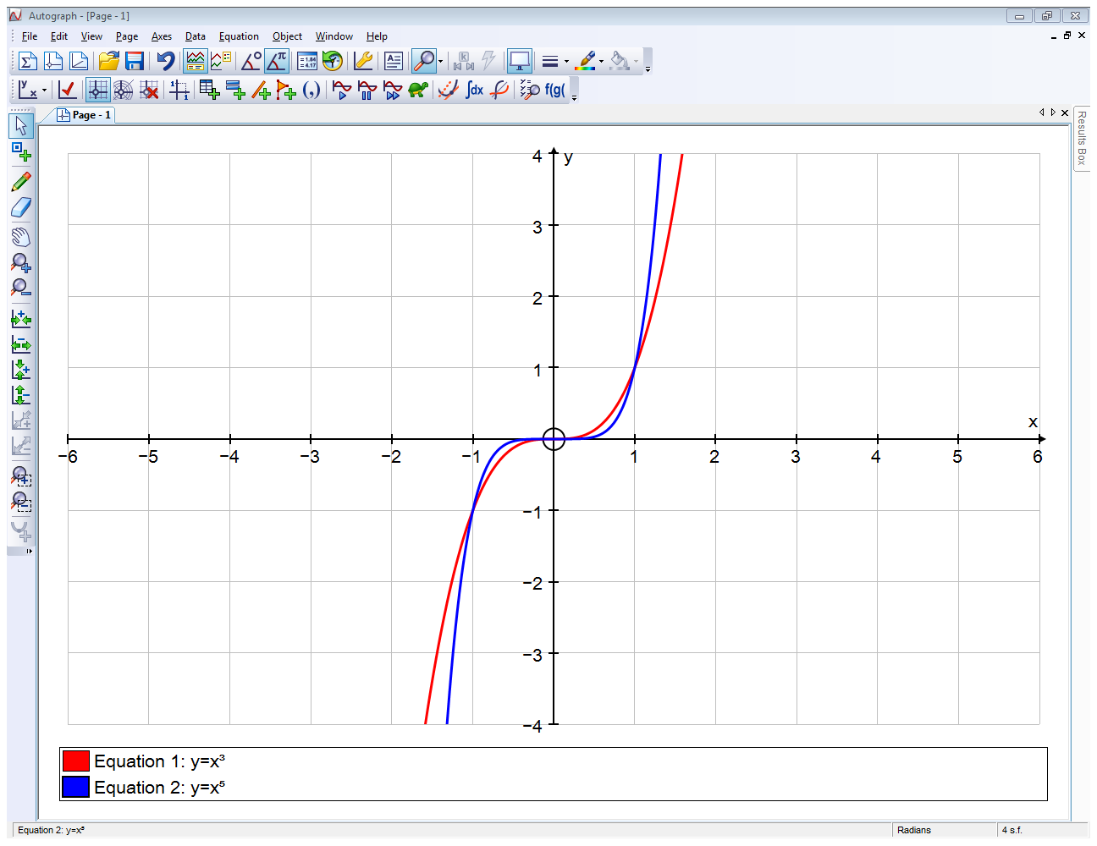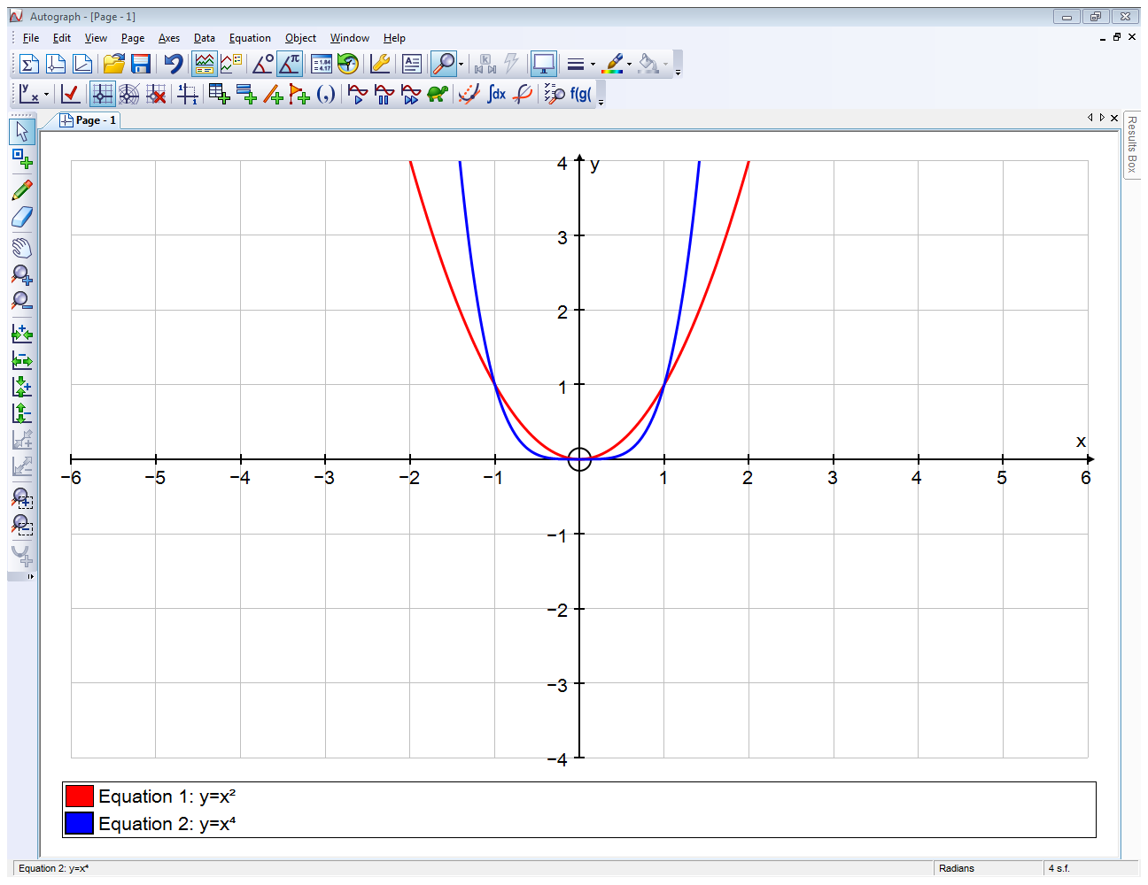**13 14**

*red: y = x*2 *blue: y = x*4*red: y = x*3 *blue: y = x*5